**PROJECT**

**Chat Application**

**GROUP: 1**

**Nguyễn Lê Tài Đức**

**Lê Bá Thịnh**

**Tô Cao Kim Ngân**

**Trần Minh Nhựt**

Table of Contents

I. SYSTEM CONTEXT DIAGRAM 3

a. System context diagram 3

b. Total context diagram 3

II. USE CASE DIAGRAM 4

a. Guest 5

b. User 5

c. Admin 7

III. ENITY CLASS DIAGRAM 8

IV. SEQUENCE DIAGRAM 9

a. Conversation 9

i. CreateGroupConversation 9

ii. DeleteConversation 10

iii. GetConversation 11

iv. GetMemberListByConversationId 12

v. GroupAddUser 13

vi. GroupBlockUser 14

vii. GroupDisband 15

viii. SendClientMessage 16

ix. UpdateGroupConversation 17

x. UserExitGroup 18

xi. UserJoinGroup 19

b. Identity 20

i. AcceptFriendRequest 20

ii. BlockUser 21

iii. DeleteFriend 22

iv. DeleteFriendRequest 23

v. GetFriendListByUserId 24

vi. GetFriendRequestByUserId 25

vii. GetUserById 26

viii. HelperSequenceDiagram 27

ix. Login 29

x. Register 31

xi. SearchUser 32

xii. SendFriendRequest 33

xiii. UnblockUser 34

xiv. UpdateUser 35

c. Notification 36

i. UpdateNotificationStatus 36

d. Post 37

i. CreateComment 37

ii. CreateInteractionEmoji 38

iii. CreatePost 39

iv. CreatePostInteraction 40

v. CreatePostReport 41

vi. CreateTag 42

vii. DeleteInteractionEmoji 43

viii. DeleteTag 44

ix. DisablePost 45

x. GetListInteractionEmoji 46

xi. GetPostById 47

xii. GetReportPostList 48

xiii. GetTagList 49

xiv. UpdateInteractionEmoji 50

xv. UpdatePost 51

xvi. UpdateTag 52

e. Websocket 53

i. Call 53

ii. SendCallEventMessageToClient 54

# SYSTEM CONTEXT DIAGRAM

## System context diagram

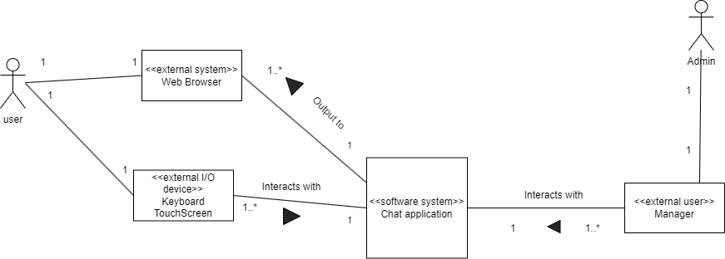

## Total context diagram

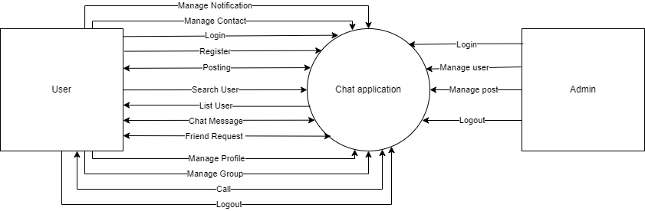

1. USE CASE DIAGRAM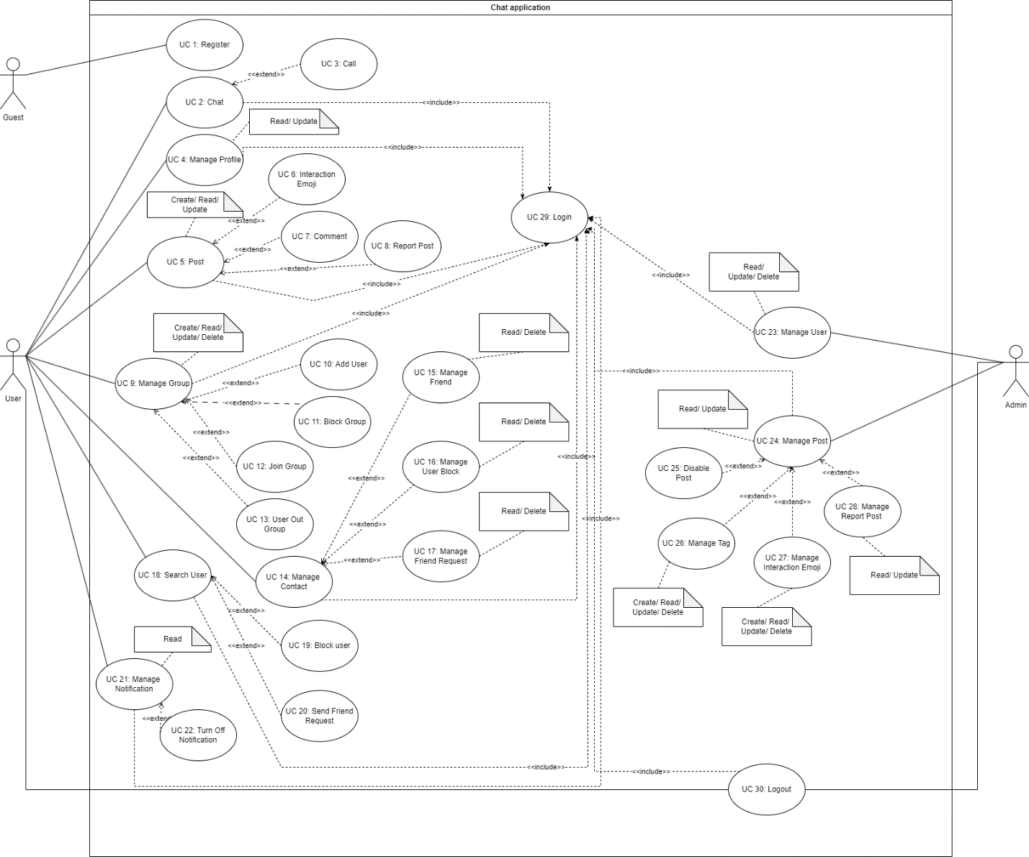

## Guest

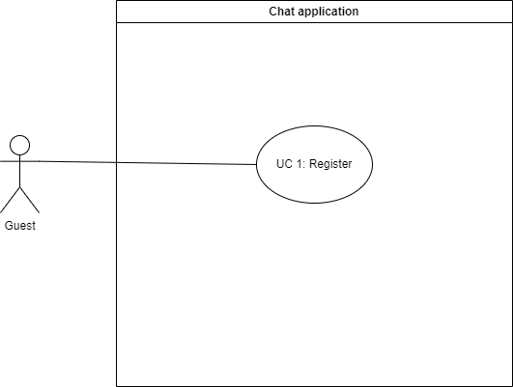

## User

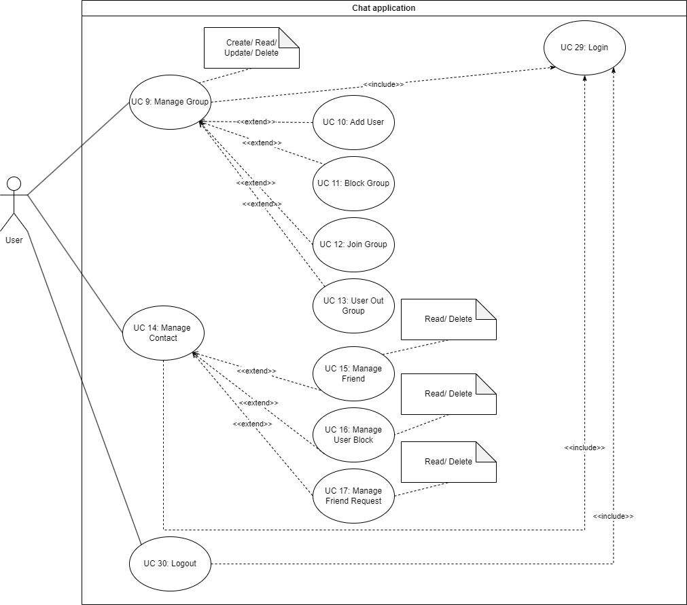

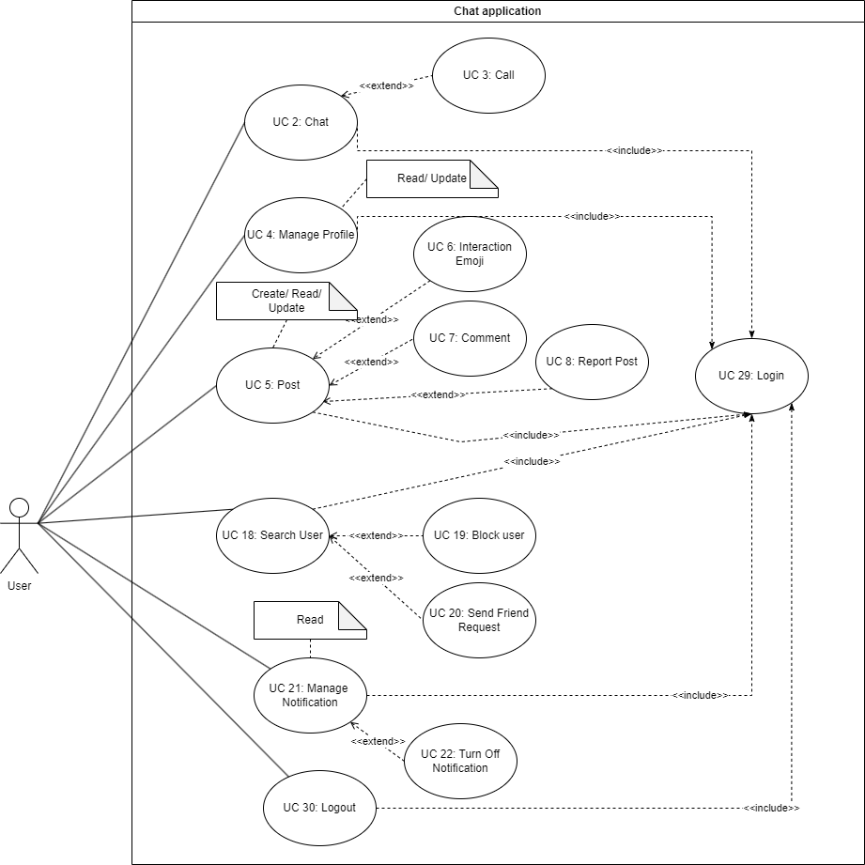

## Admin

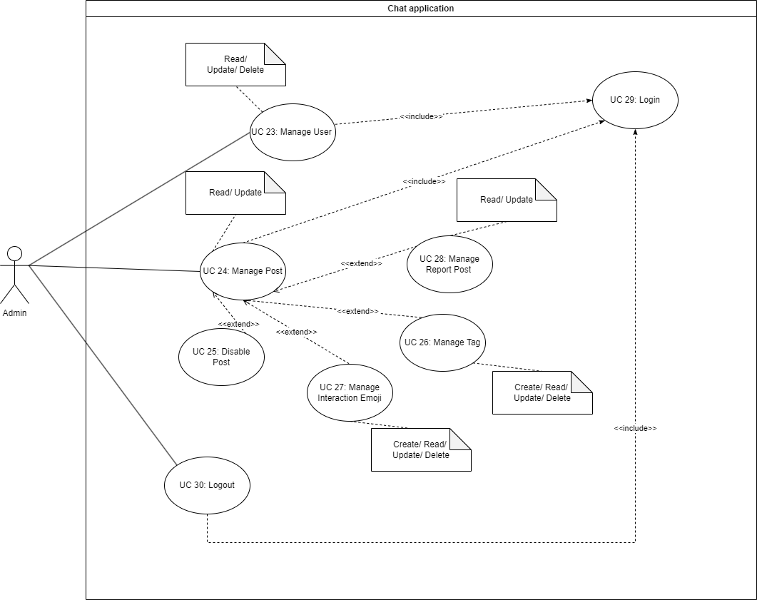

# ENITY CLASS DIAGRAM

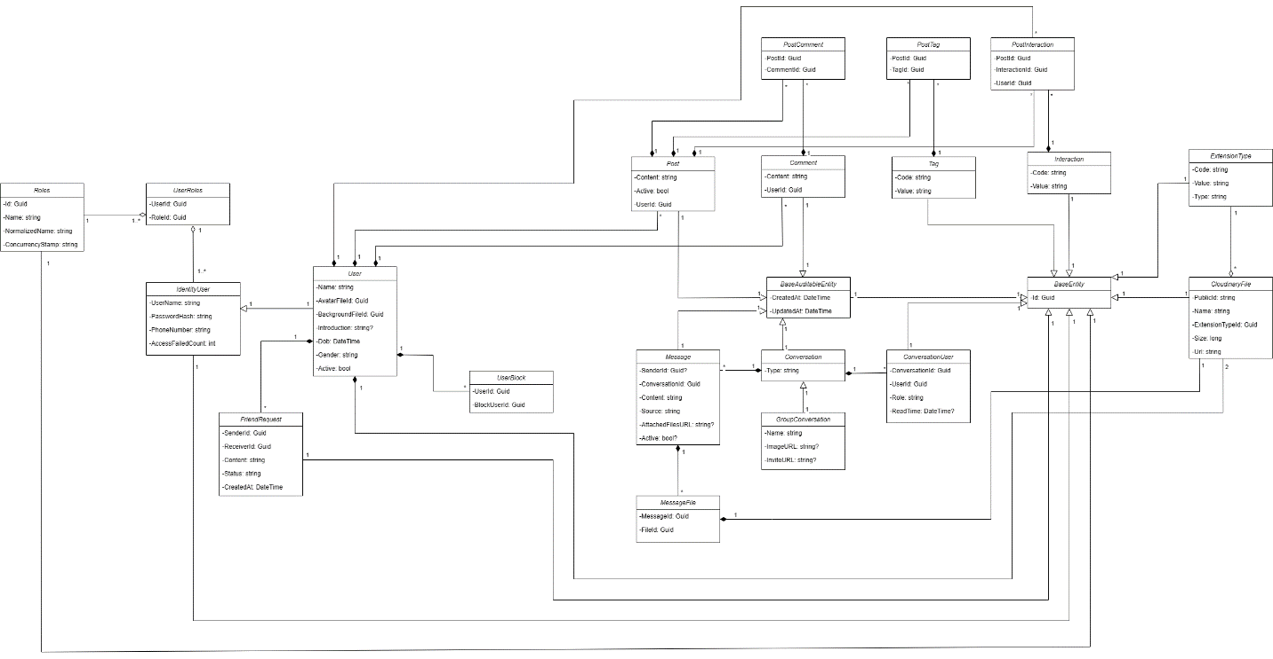

# SEQUENCE DIAGRAM

## Conversation

### CreateGroupConversation

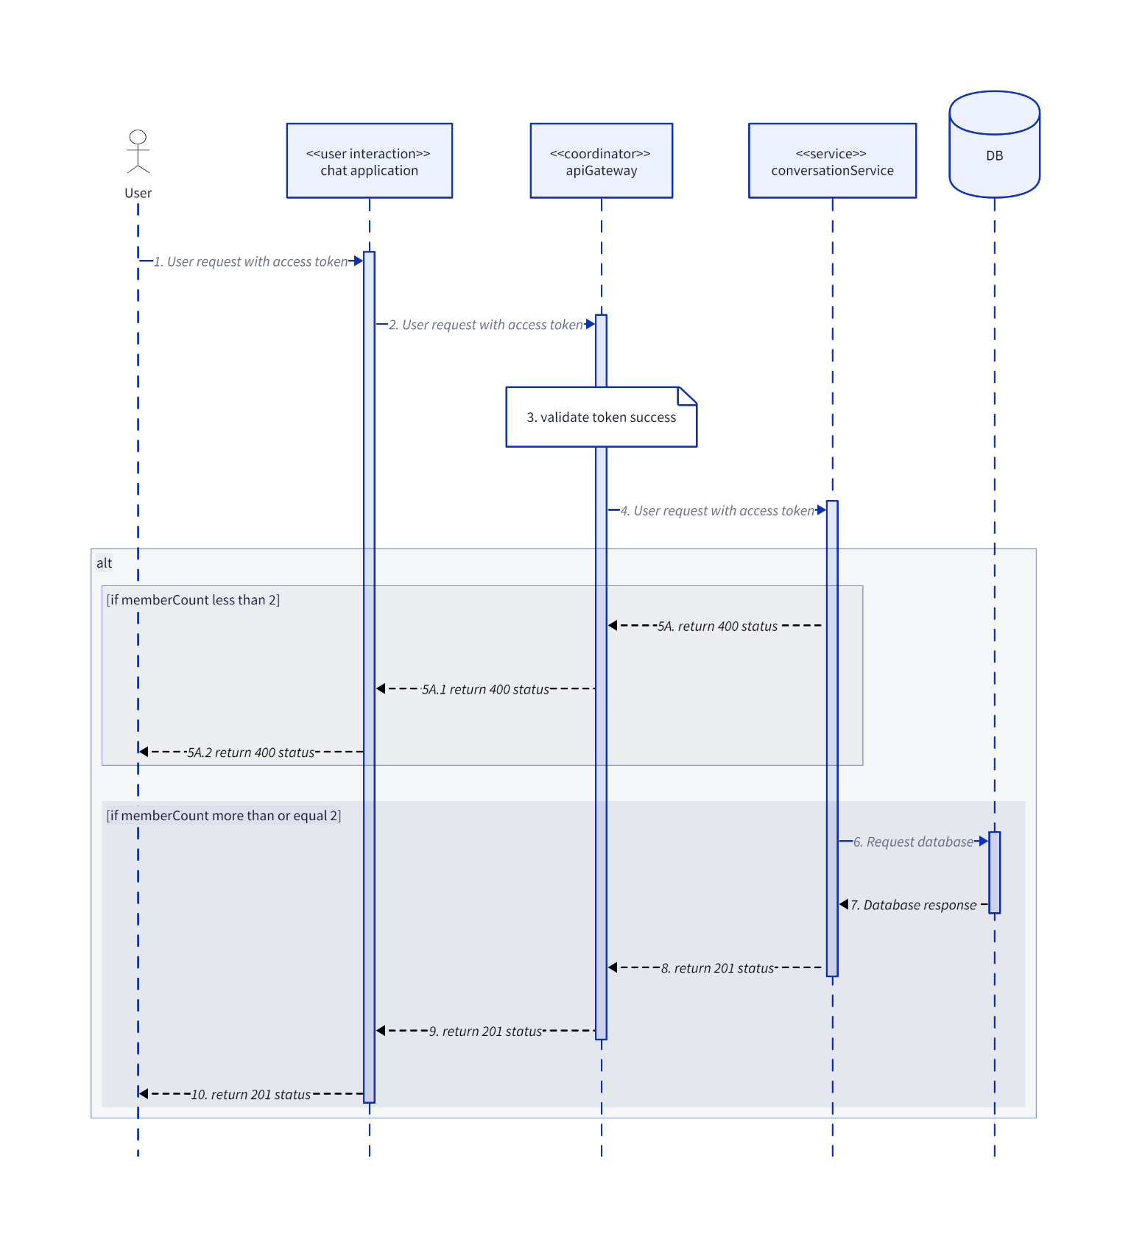

### DeleteConversation

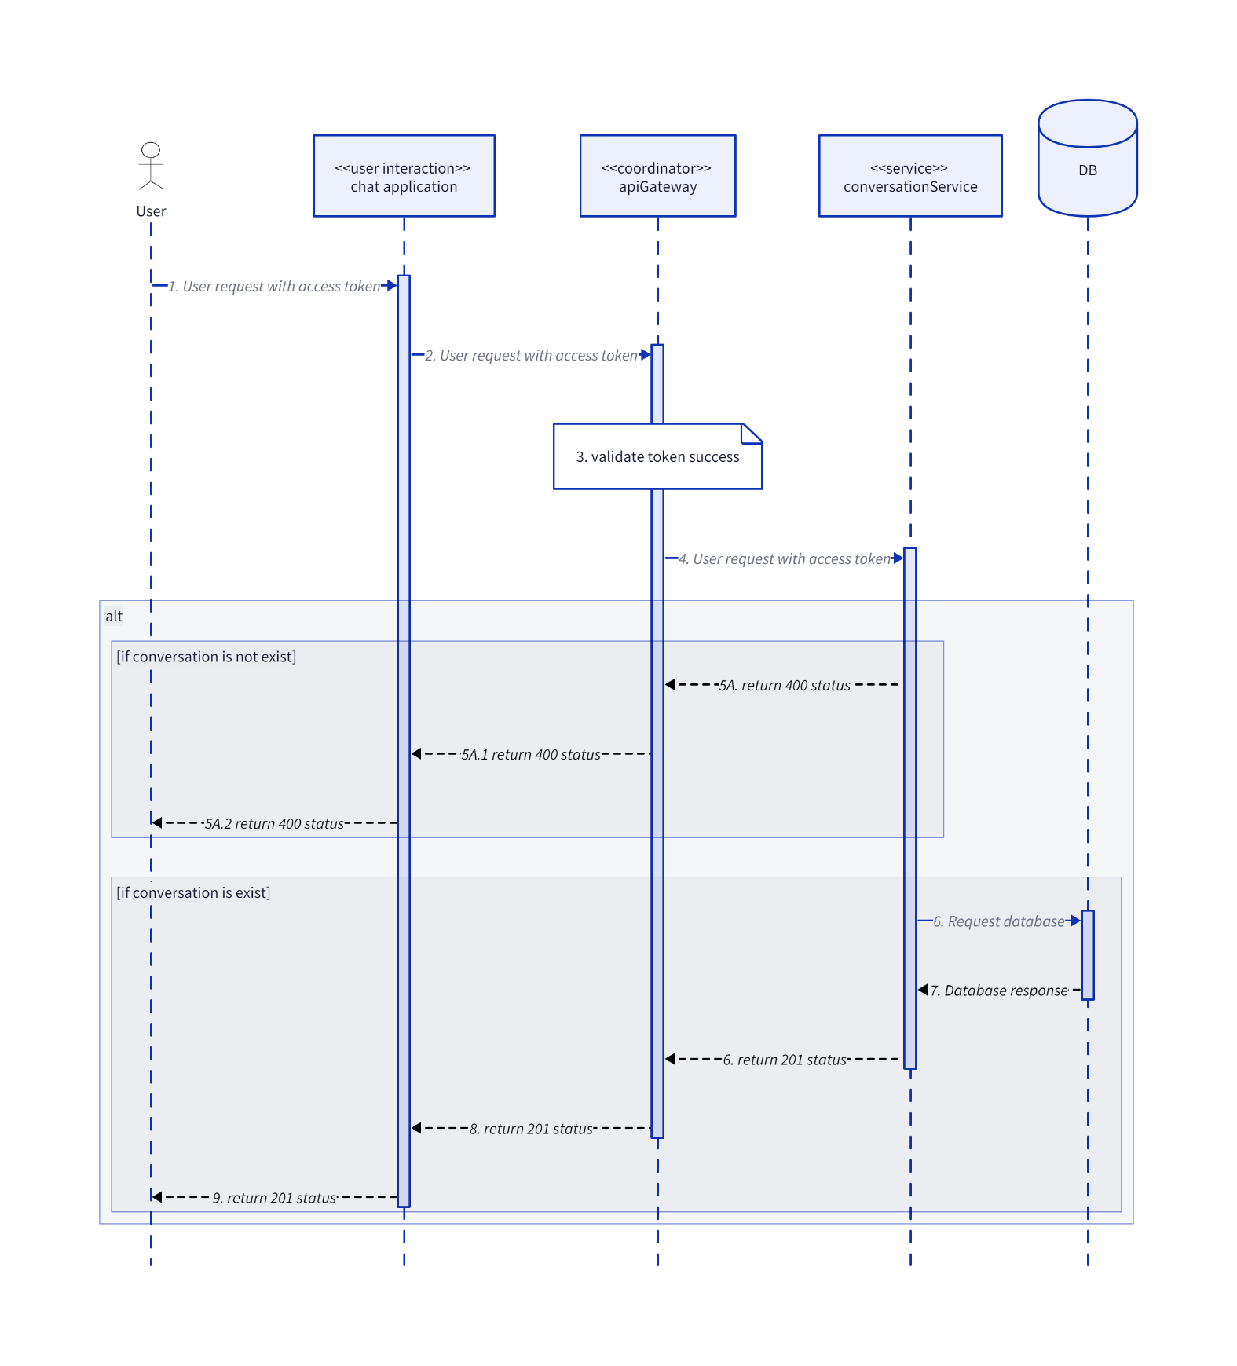

### GetConversation

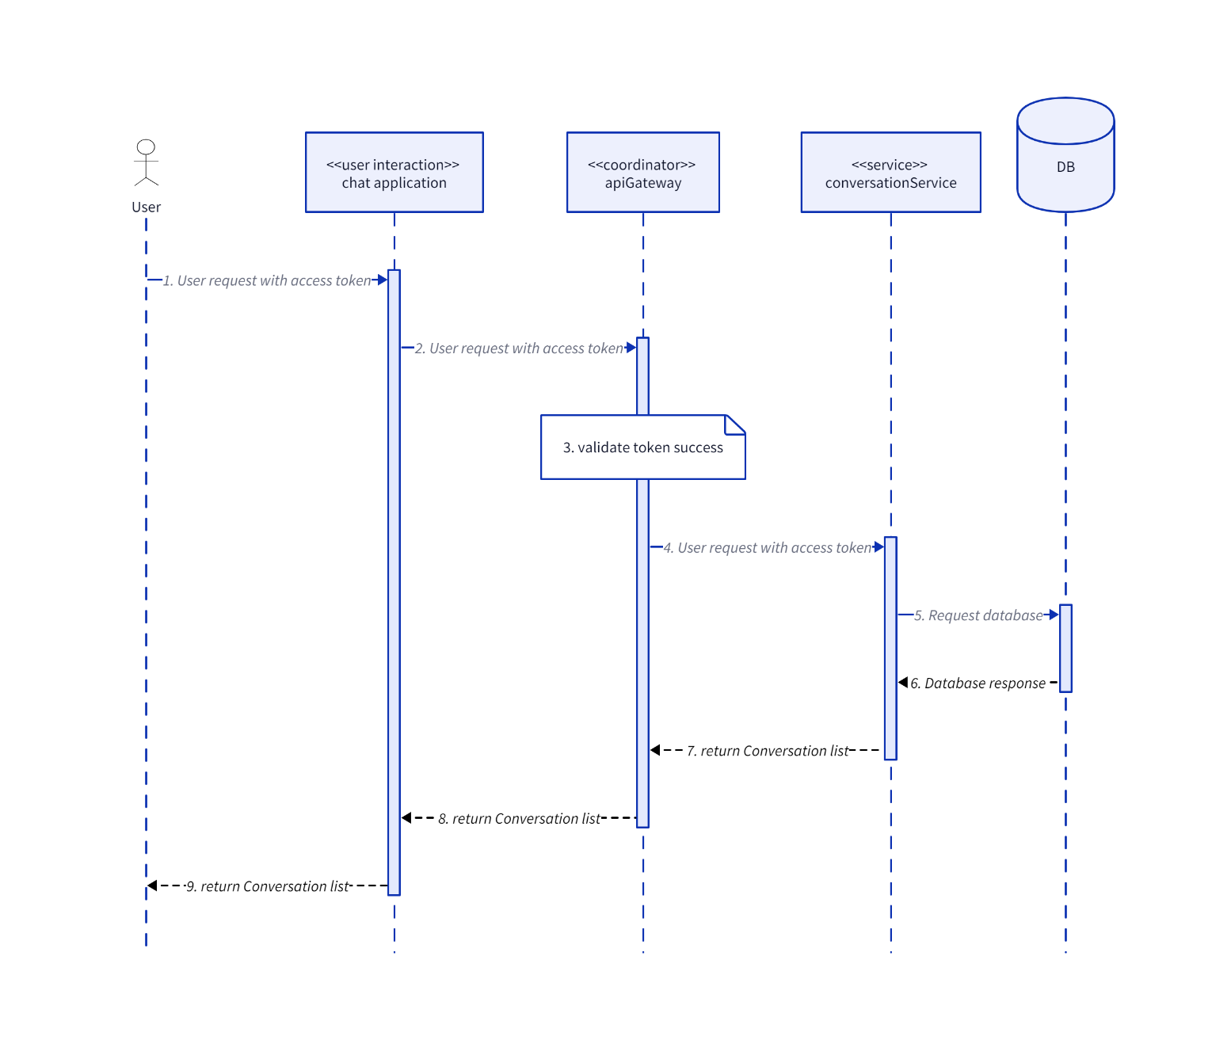

### GetMemberListByConversationId

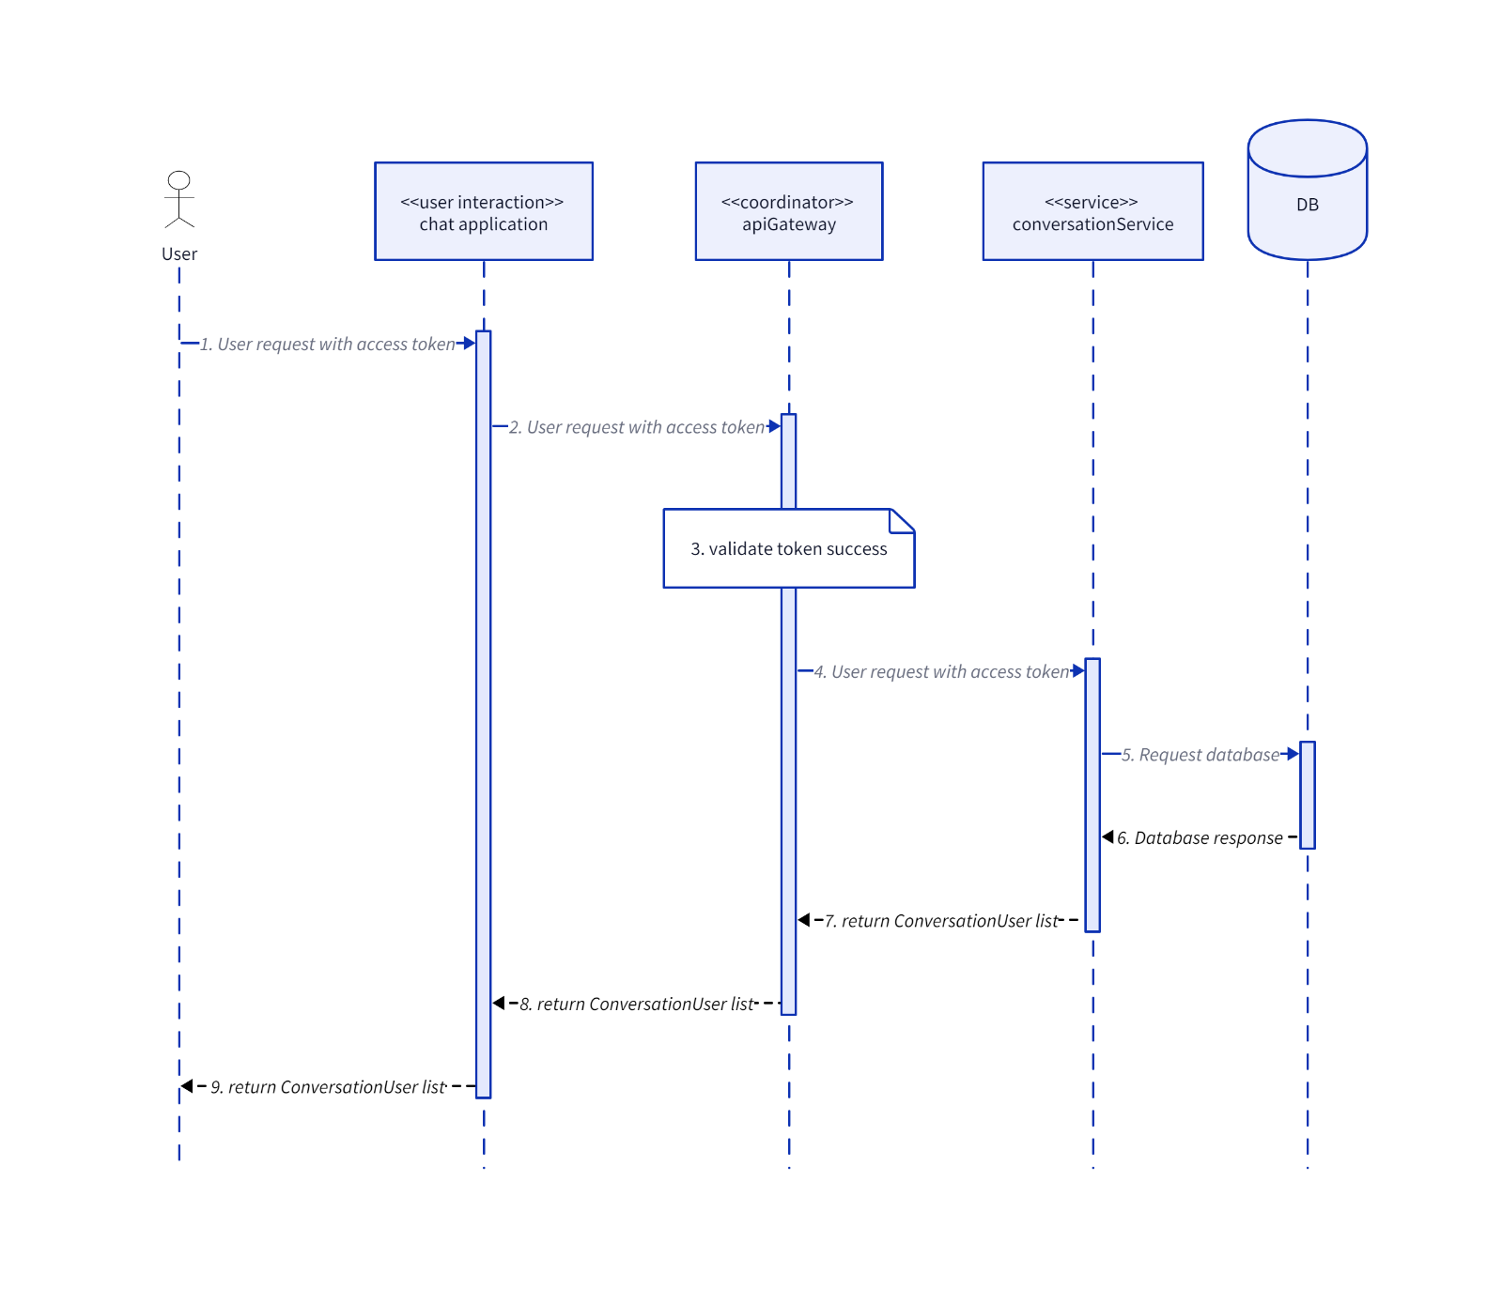

### GroupAddUser

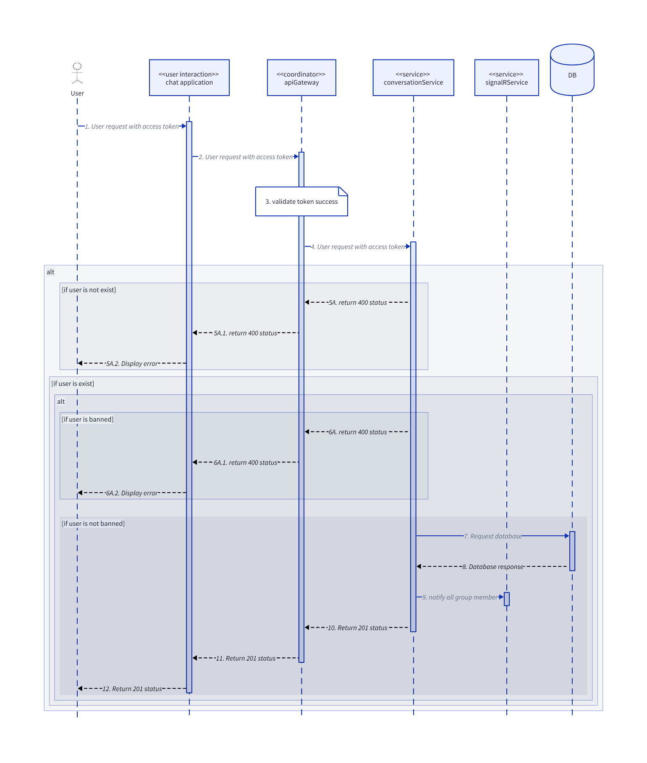

### GroupBlockUser

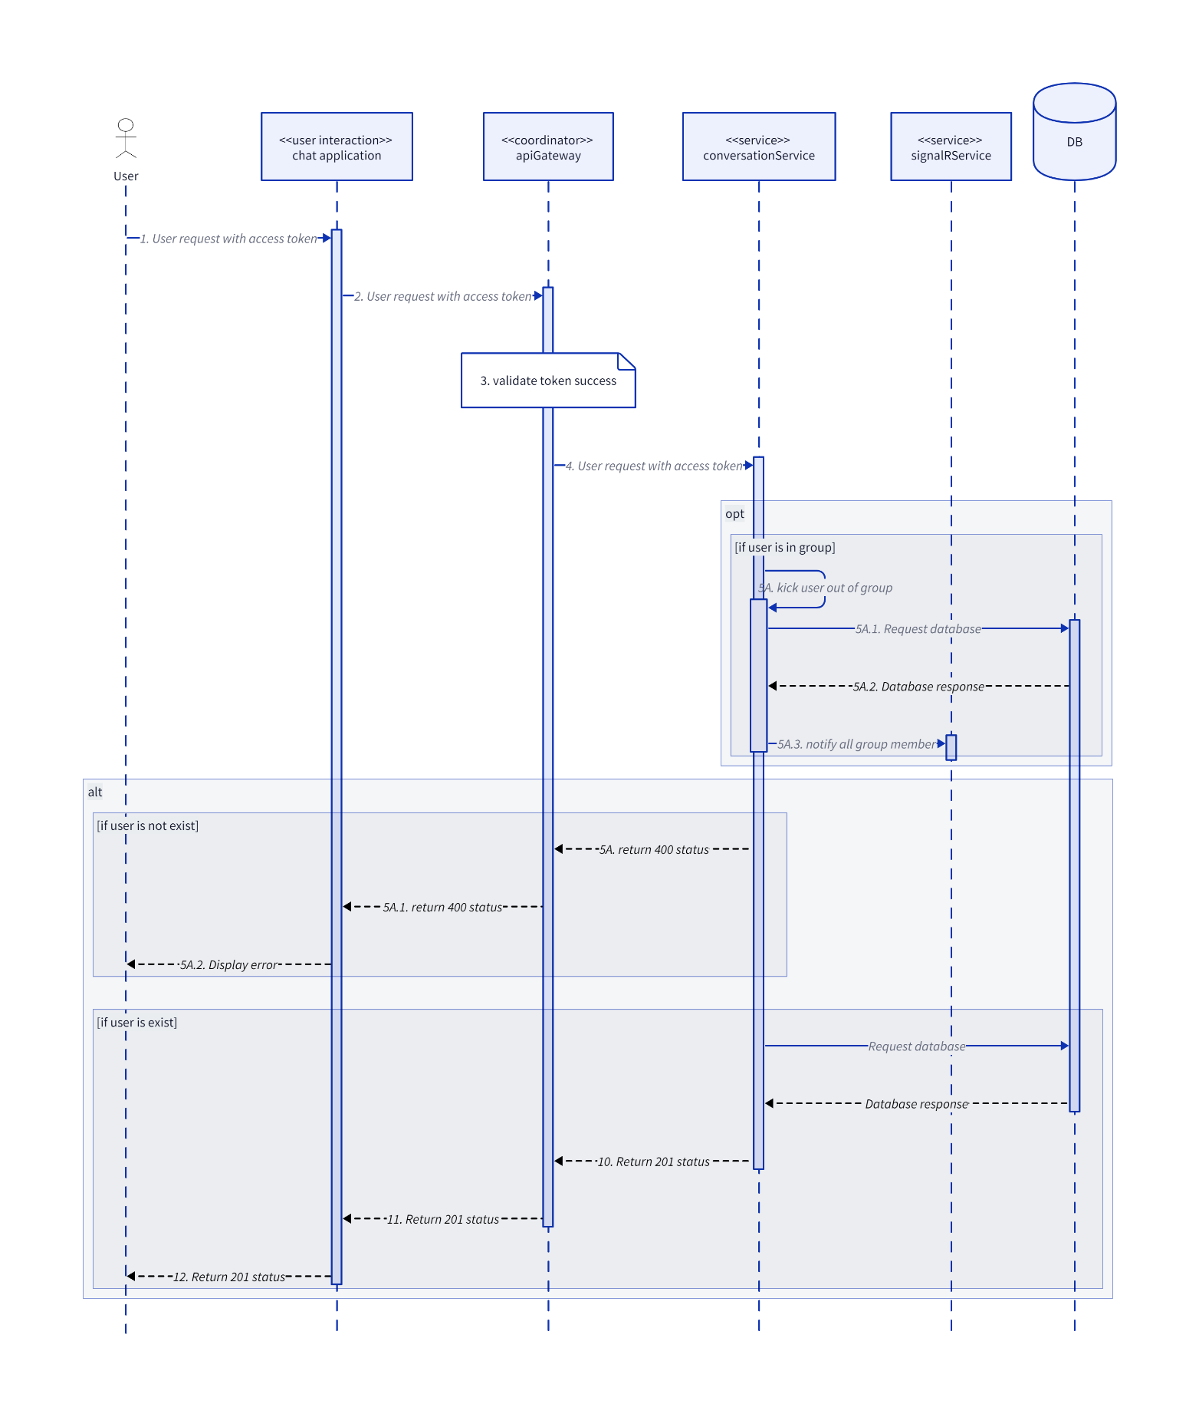

### GroupDisband

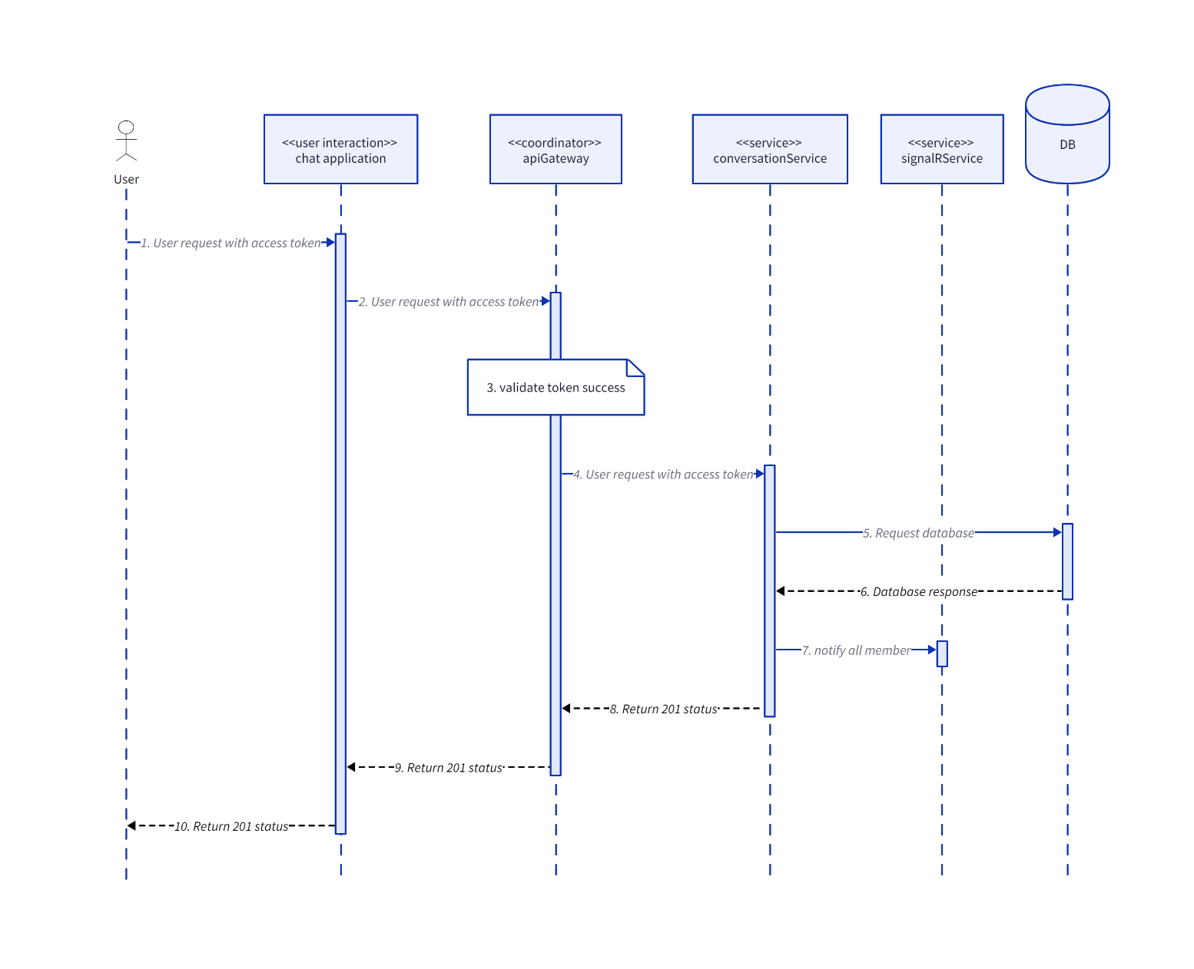

### SendClientMessage

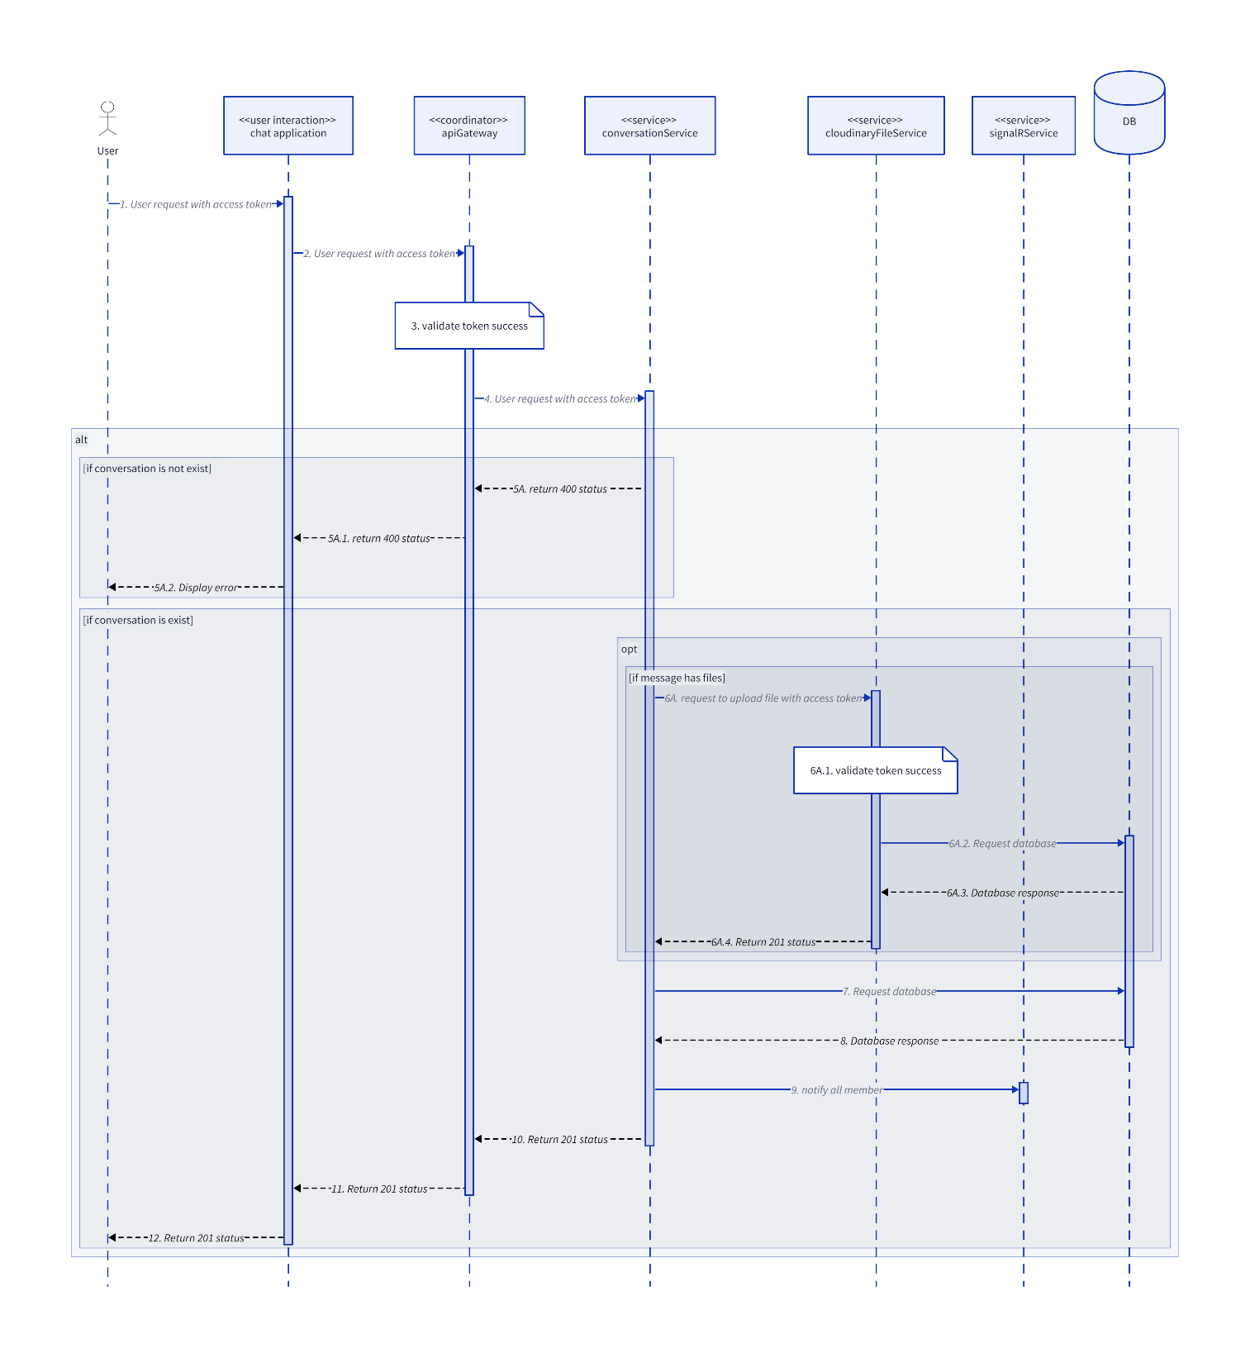

### UpdateGroupConversation

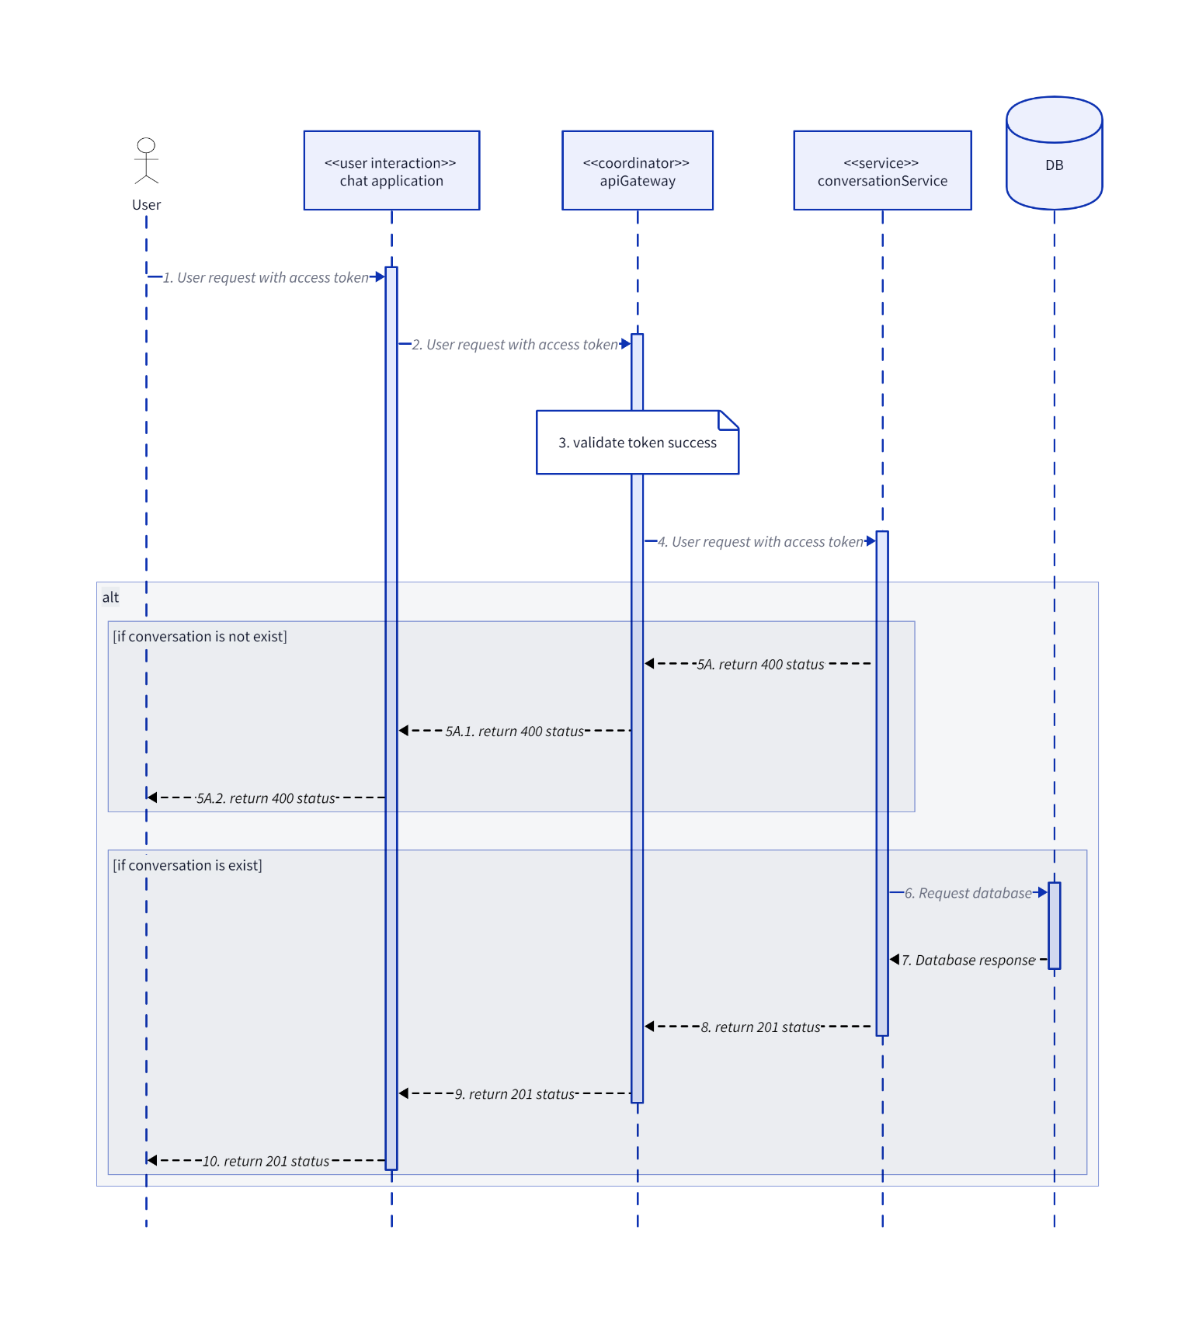

### UserExitGroup

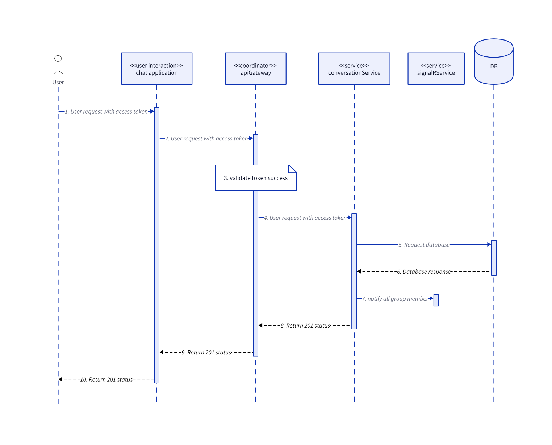

### UserJoinGroup

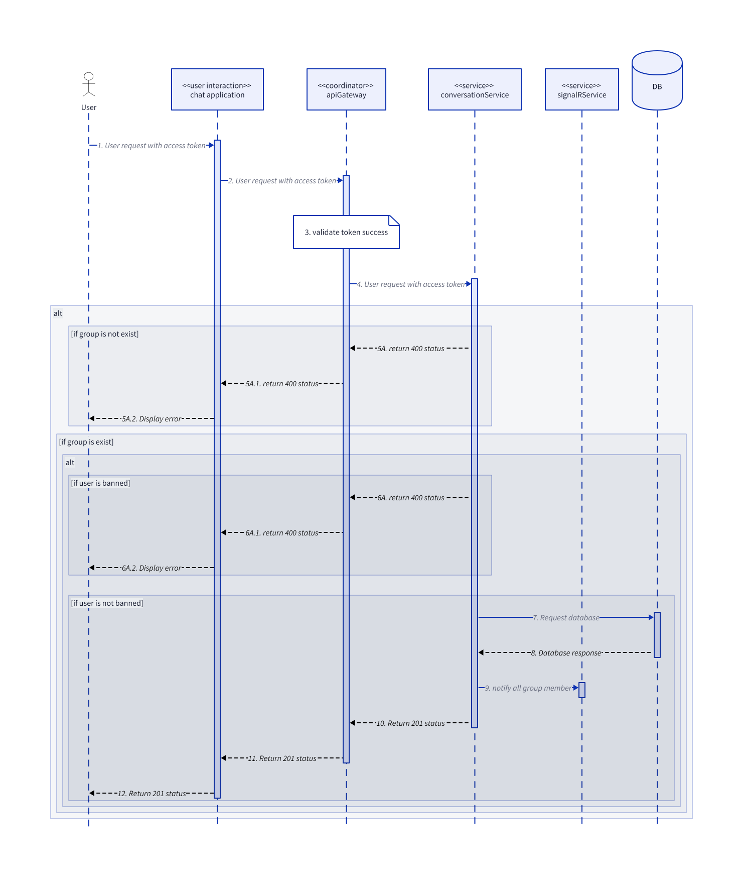

## Identity

### AcceptFriendRequest

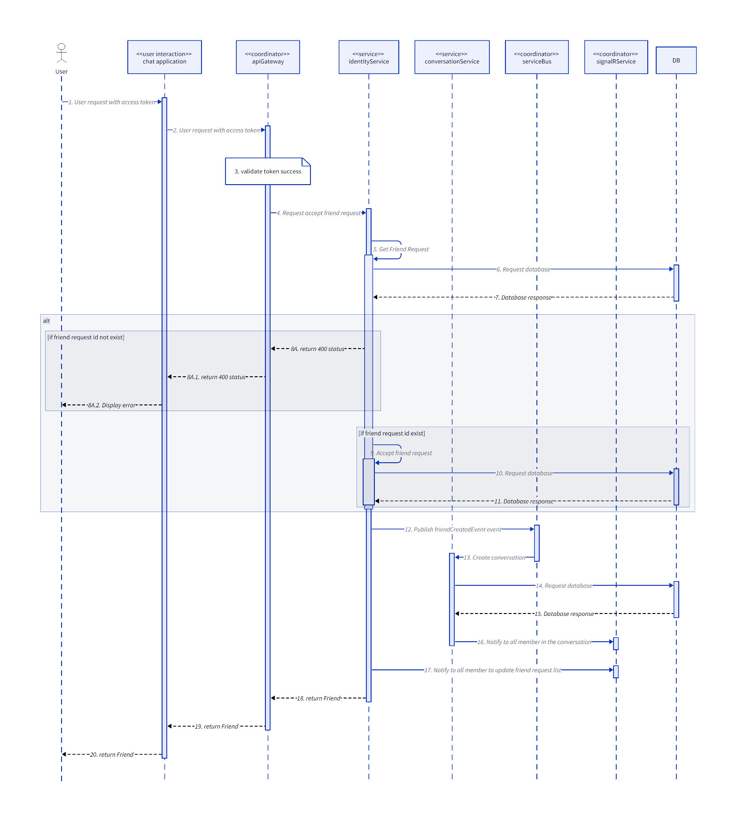

### BlockUser

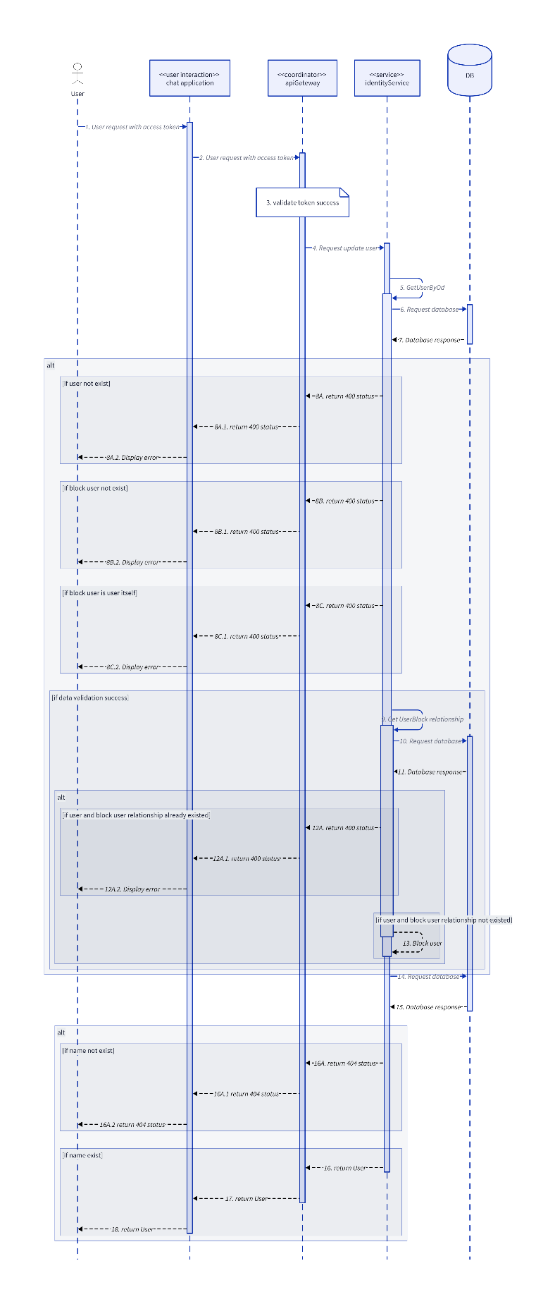

### DeleteFriend

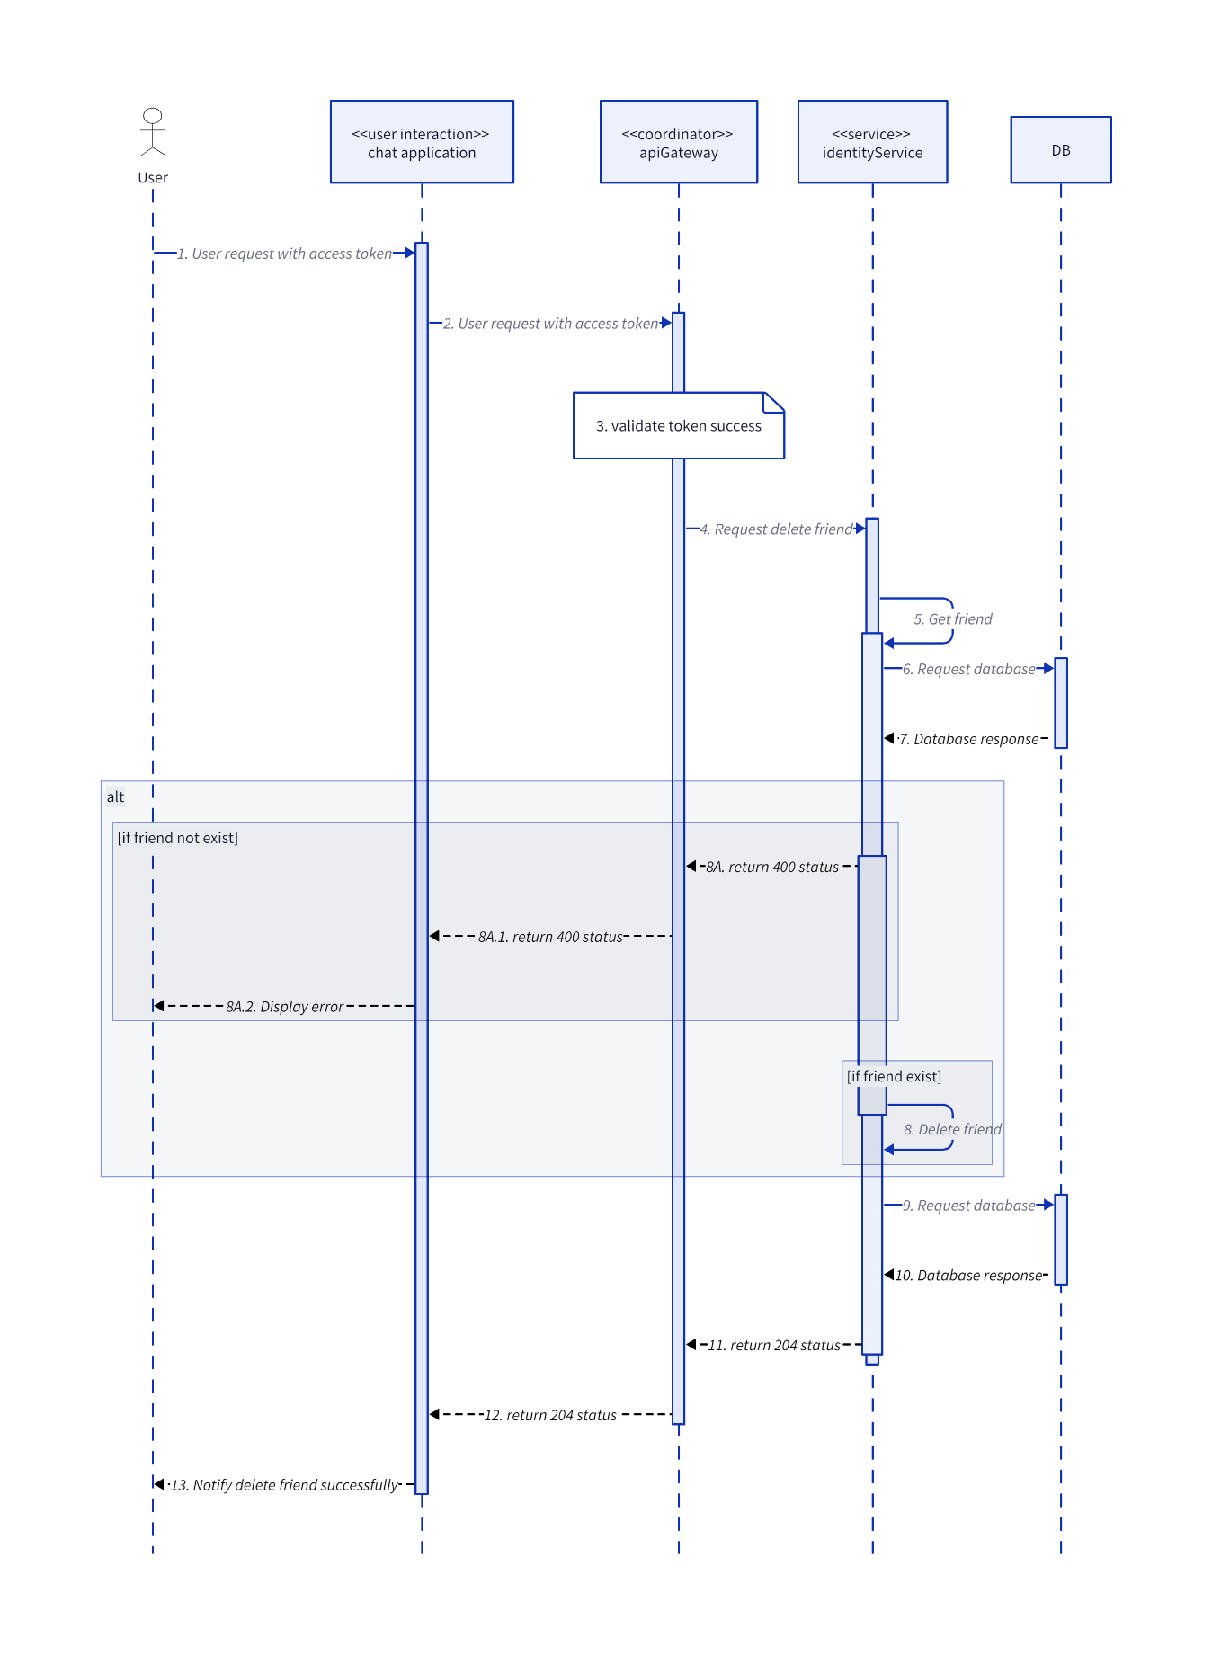

### DeleteFriendRequest

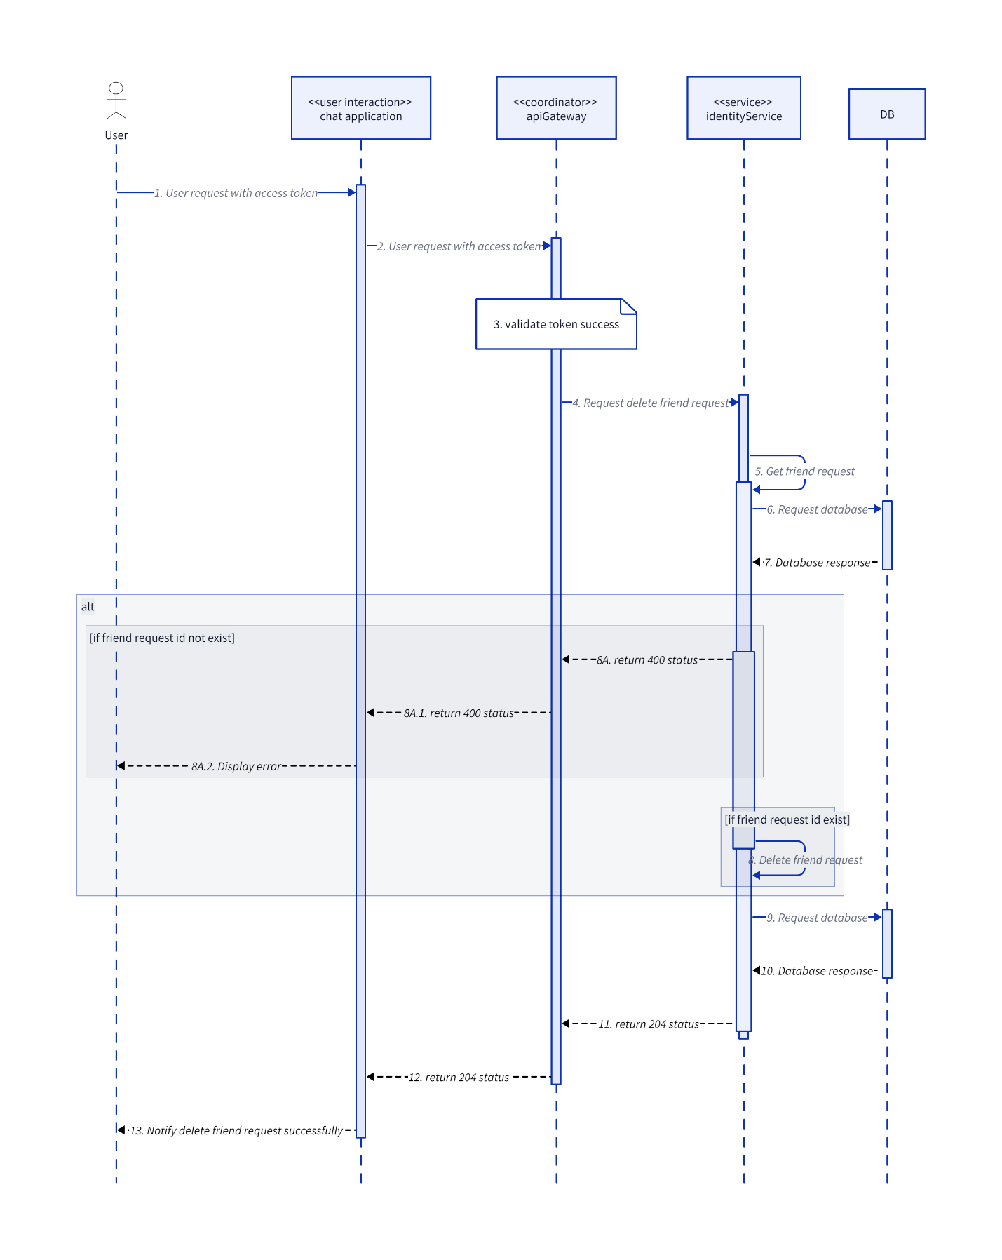

### GetFriendListByUserId

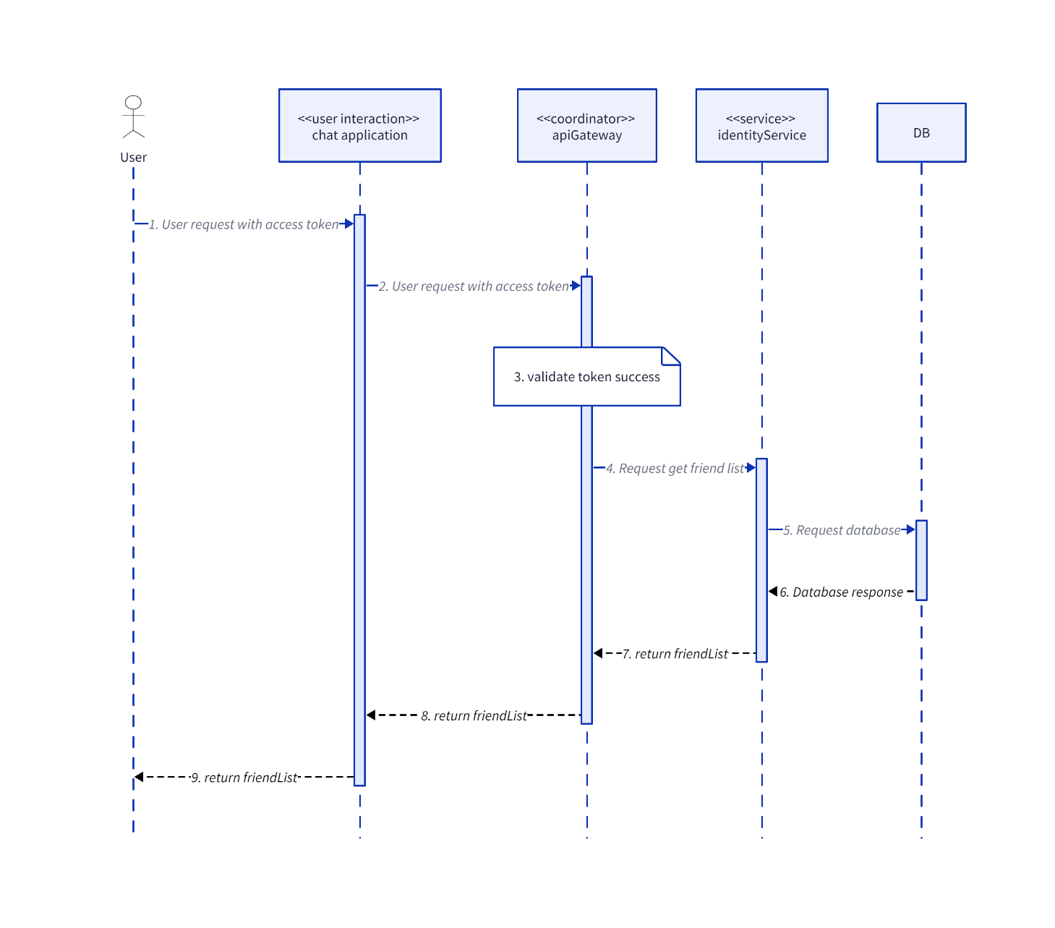

### GetFriendRequestByUserId

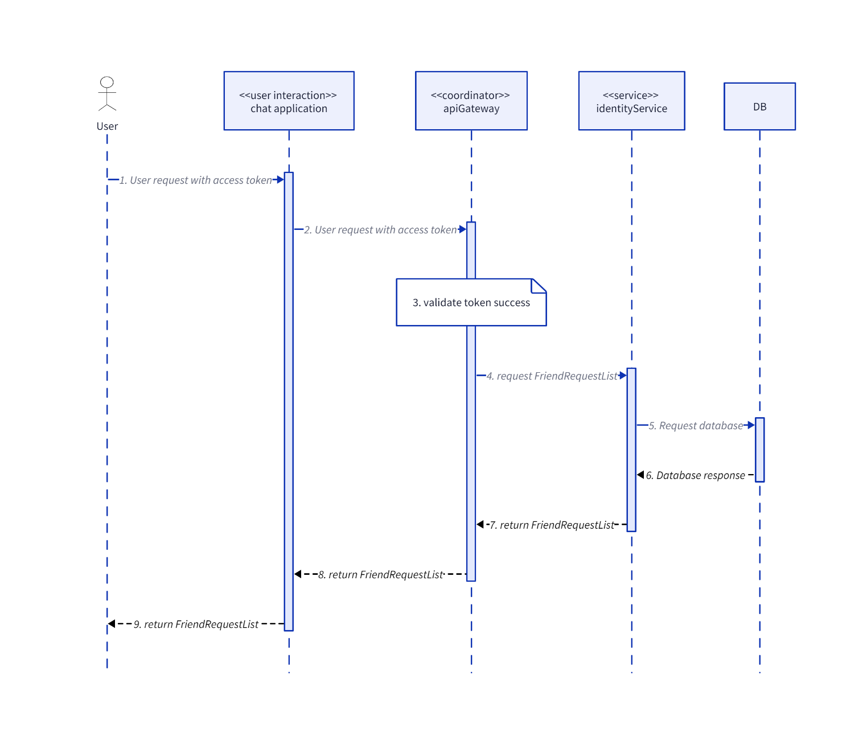

### GetUserById

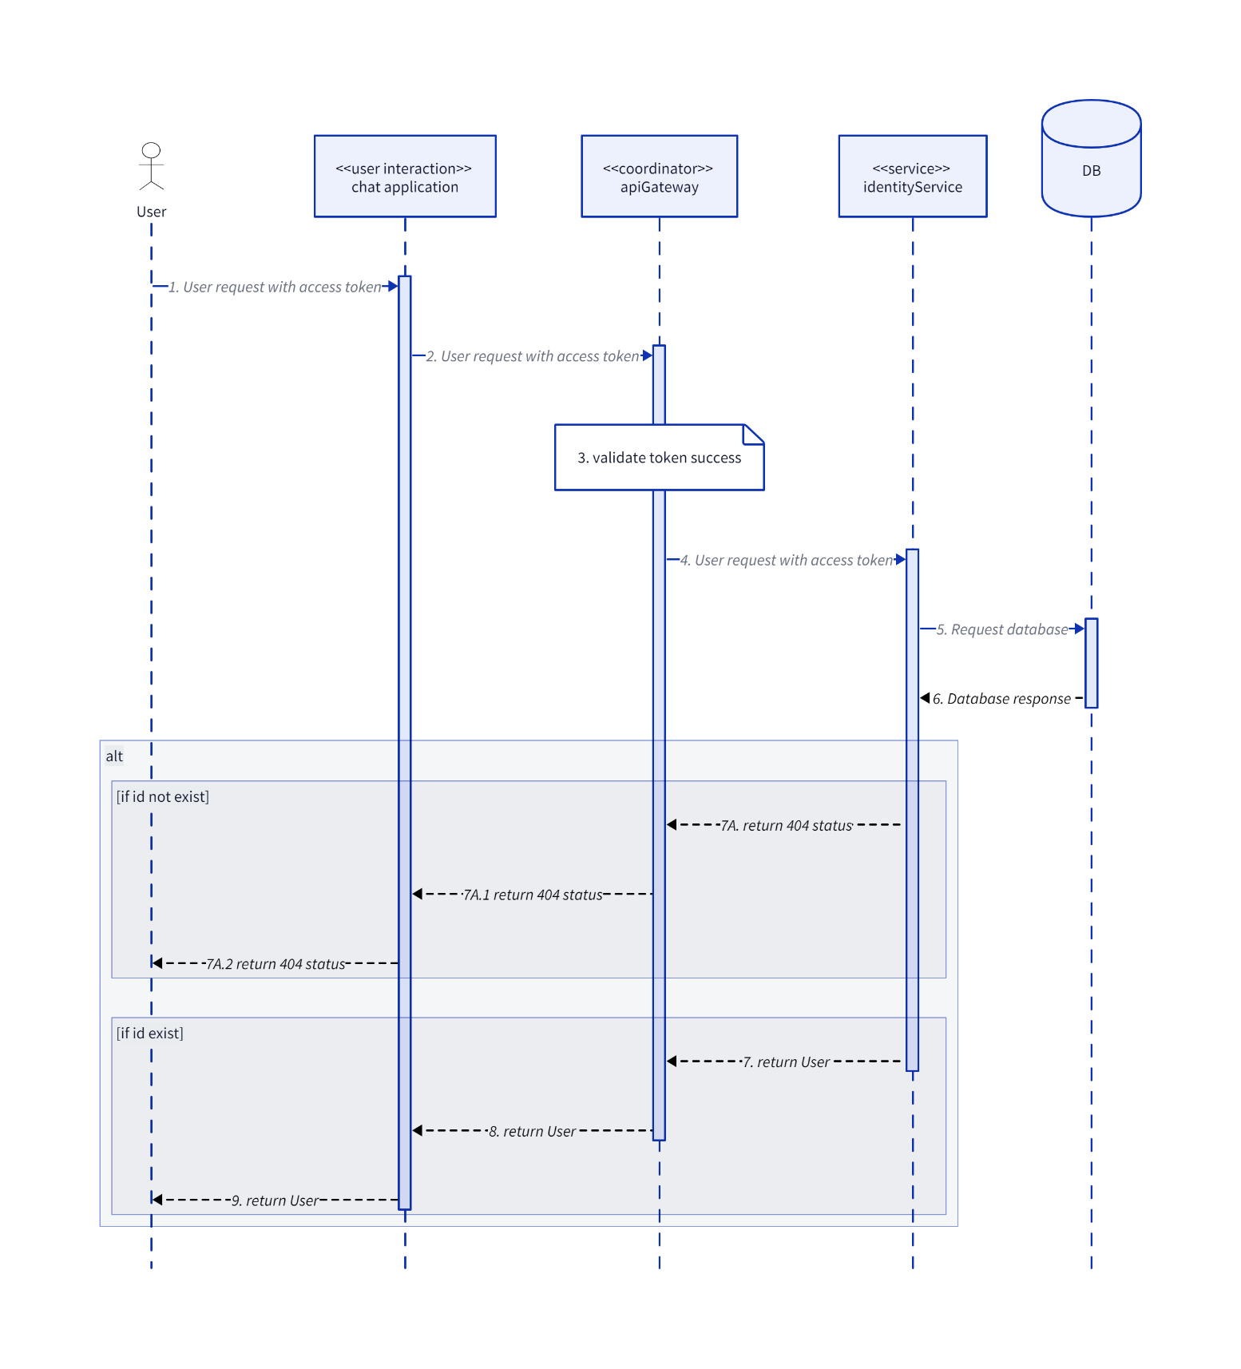

### HelperSequenceDiagram

#### UserUnauthorized

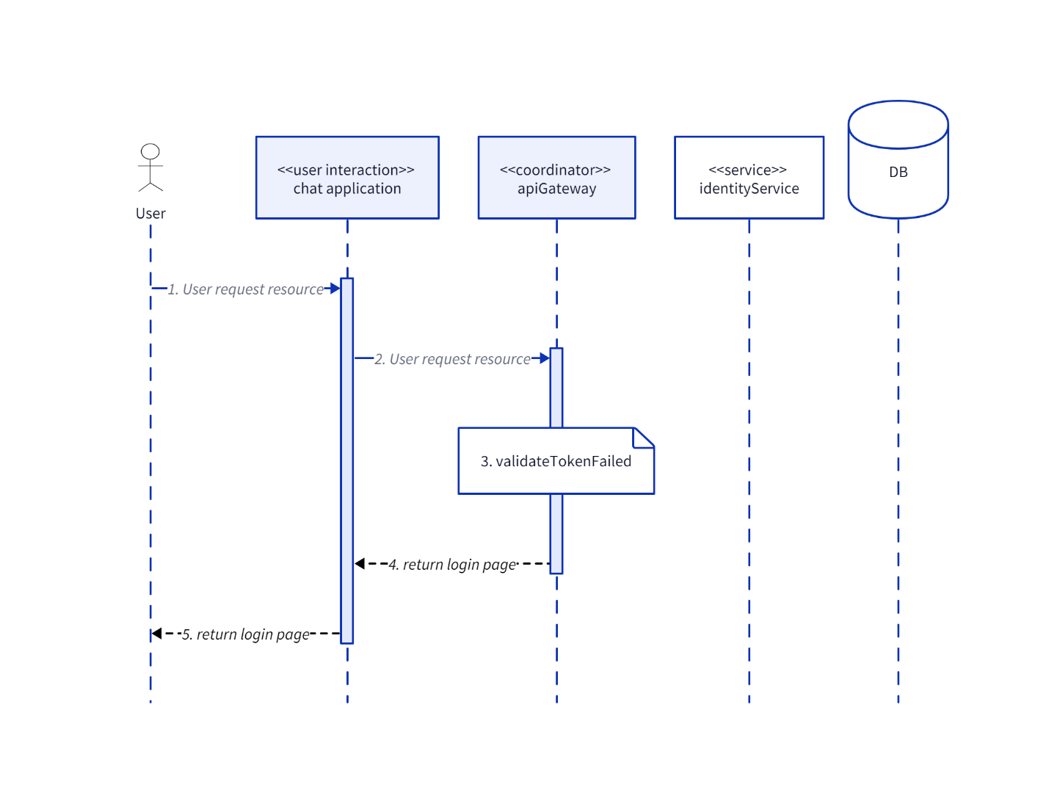

#### ValidateToken

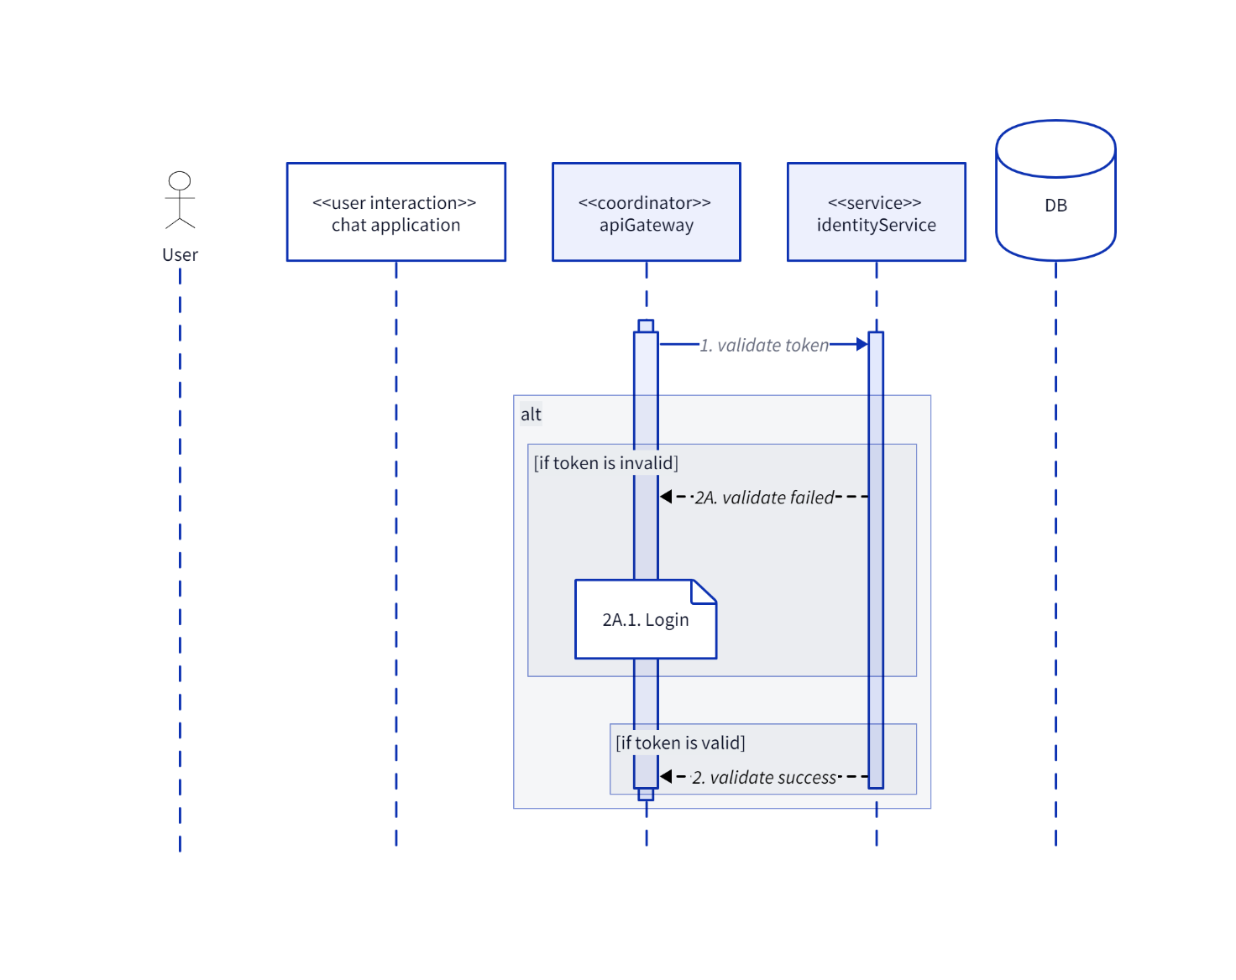

### Login

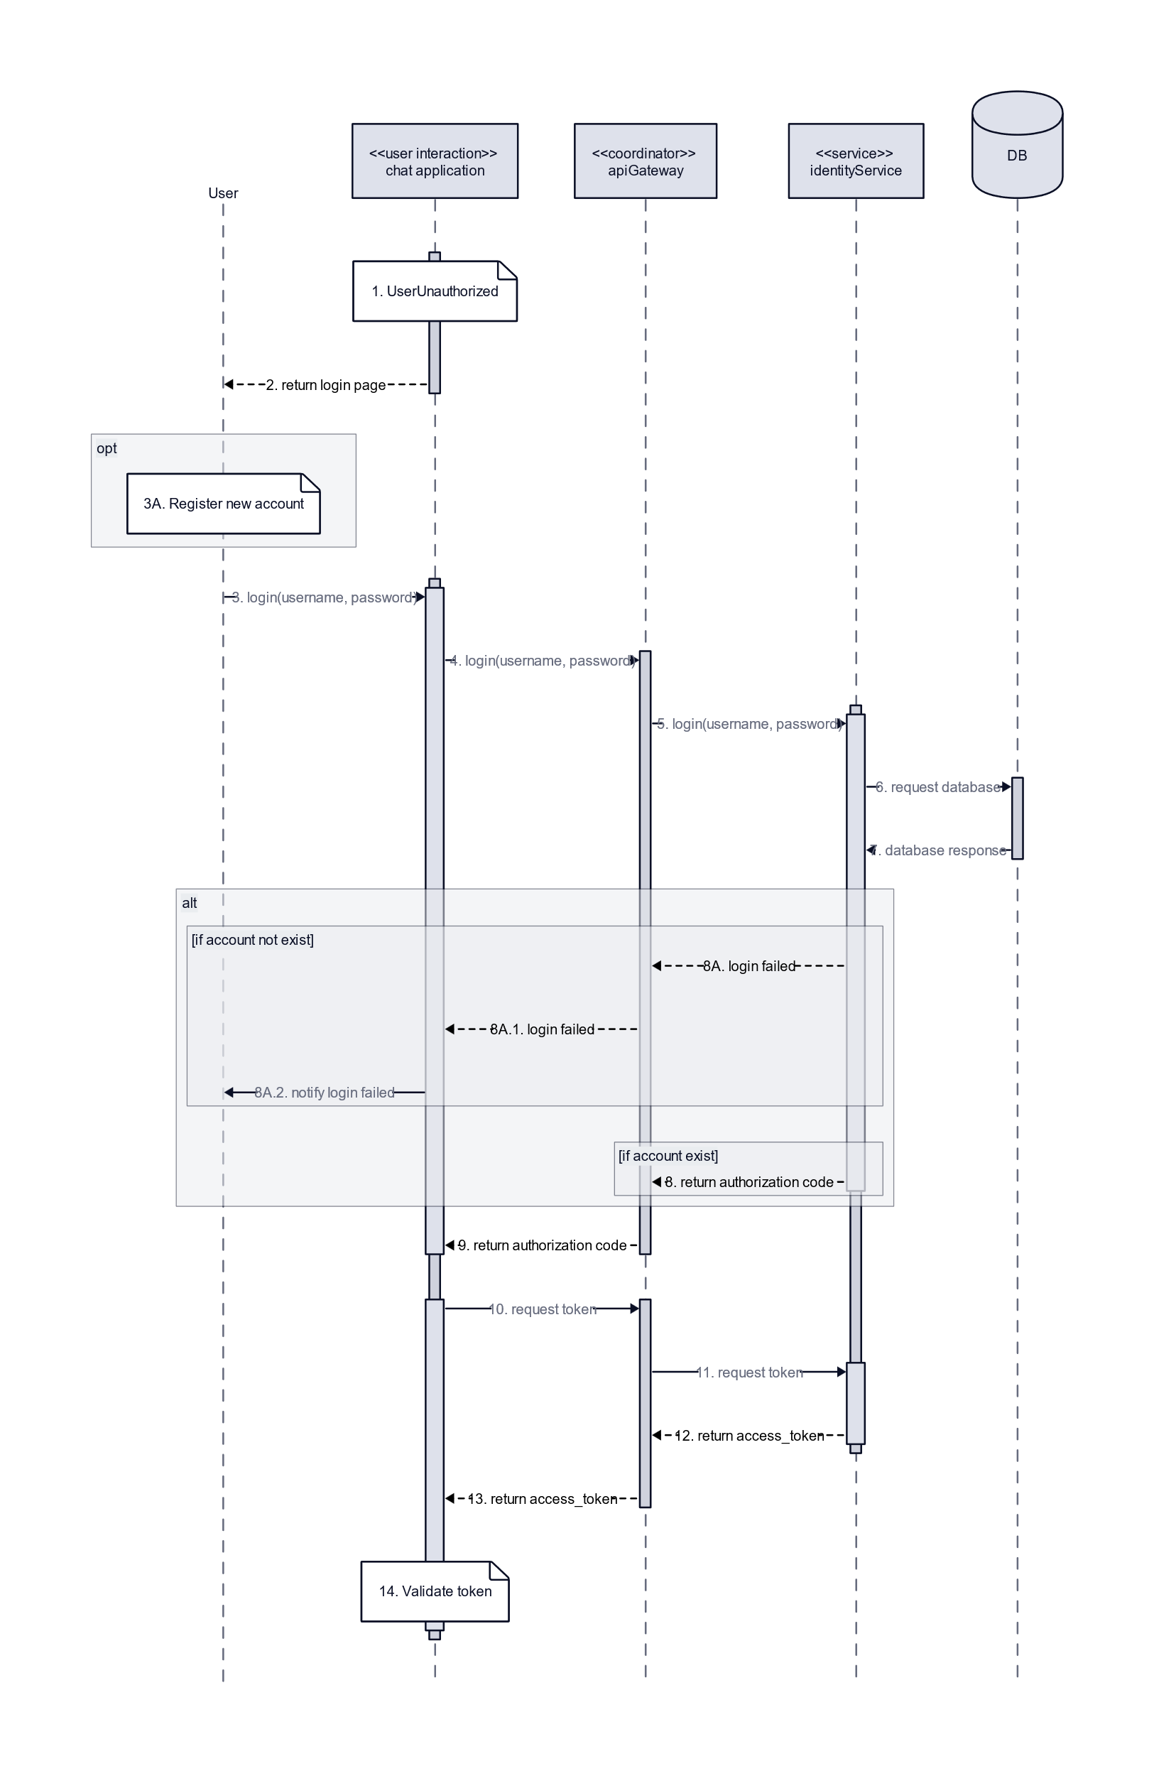

### Register

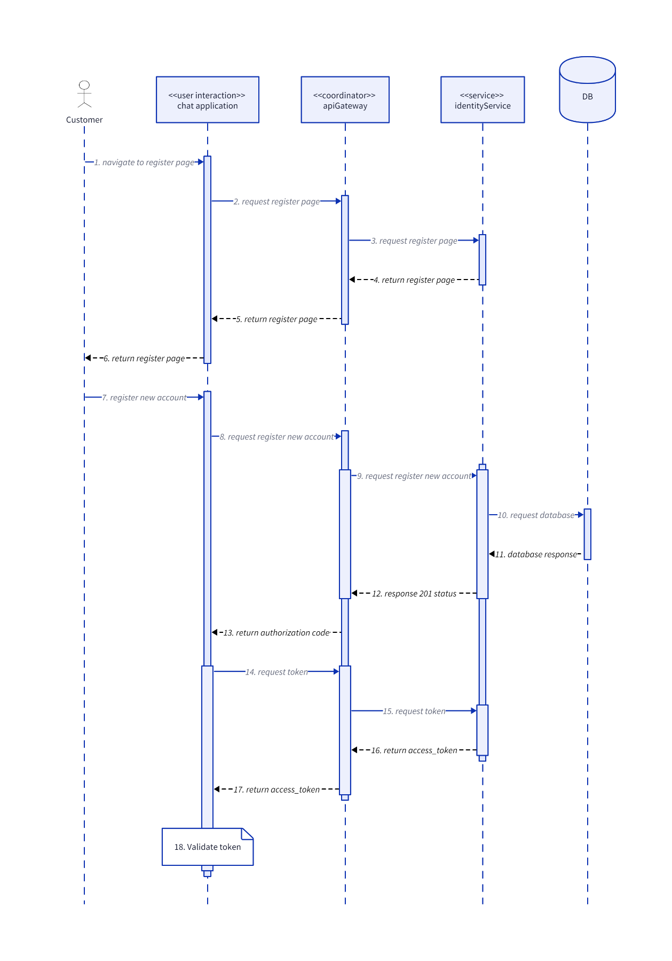

### SearchUser

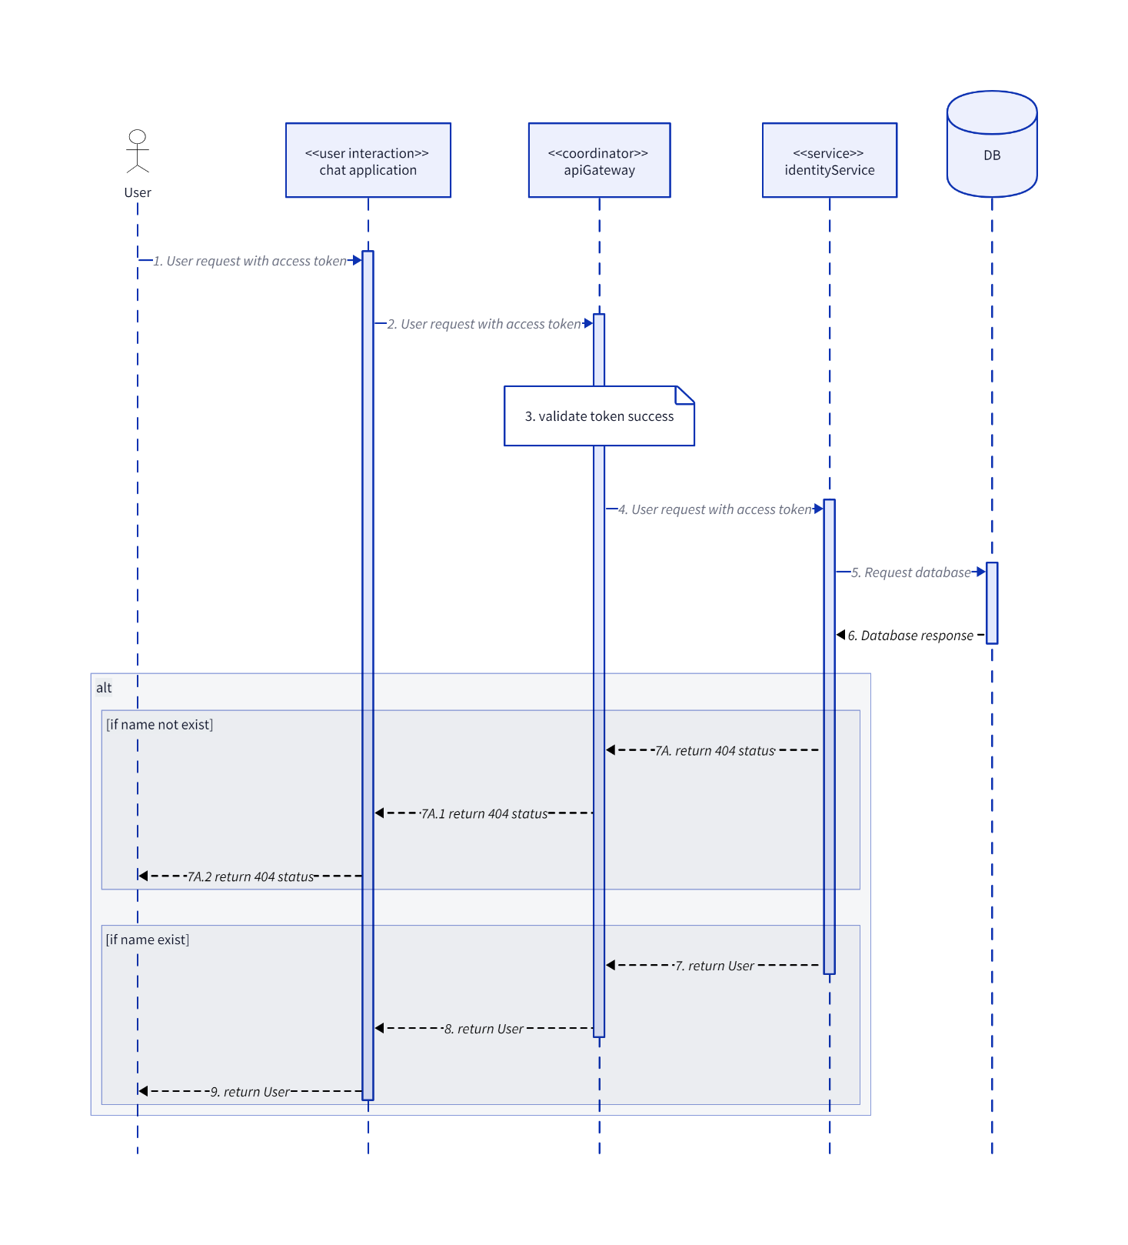

### SendFriendRequest

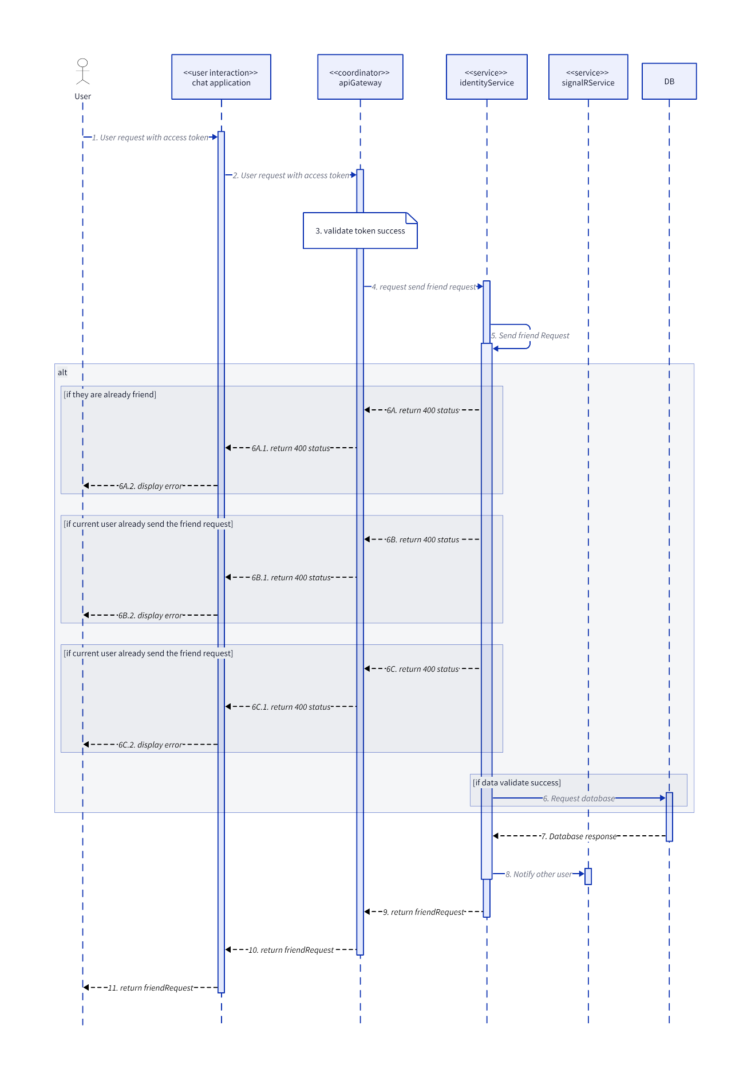

### UnblockUser

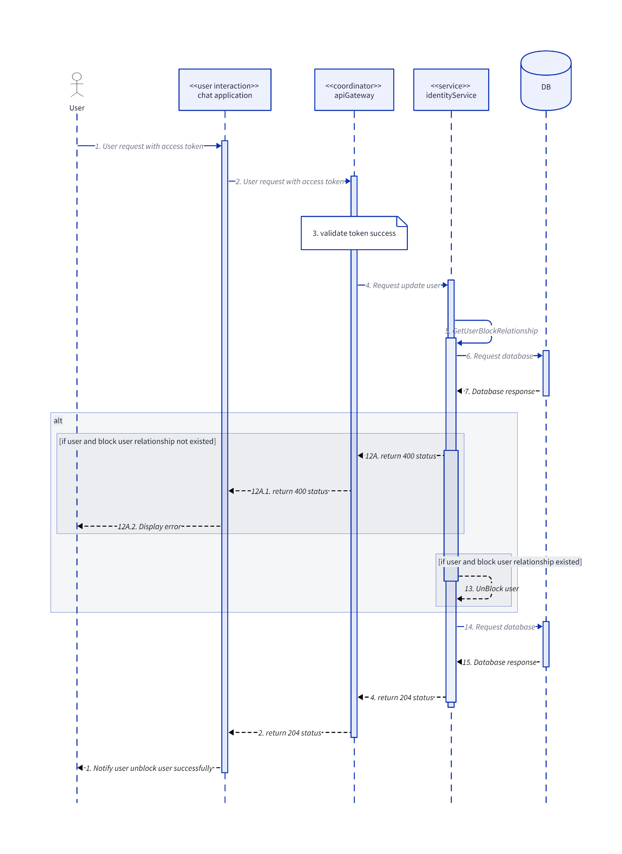

### UpdateUser

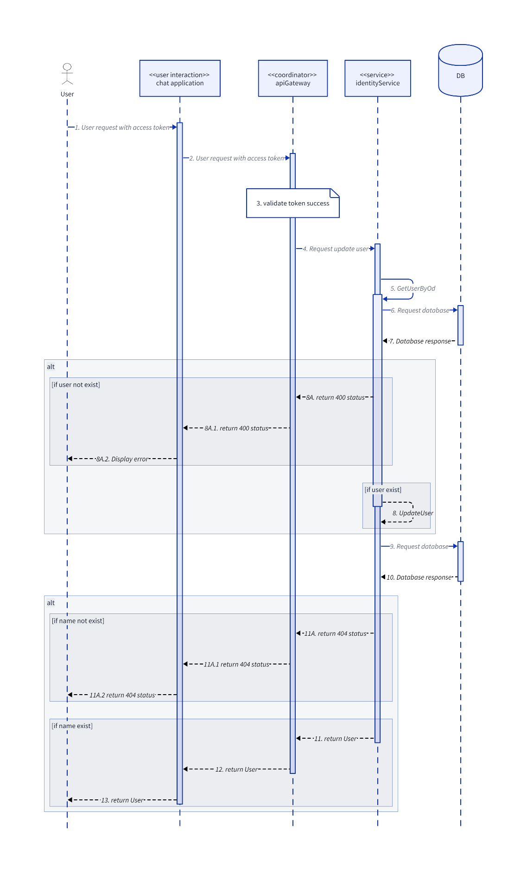

## Notification

### UpdateNotificationStatus

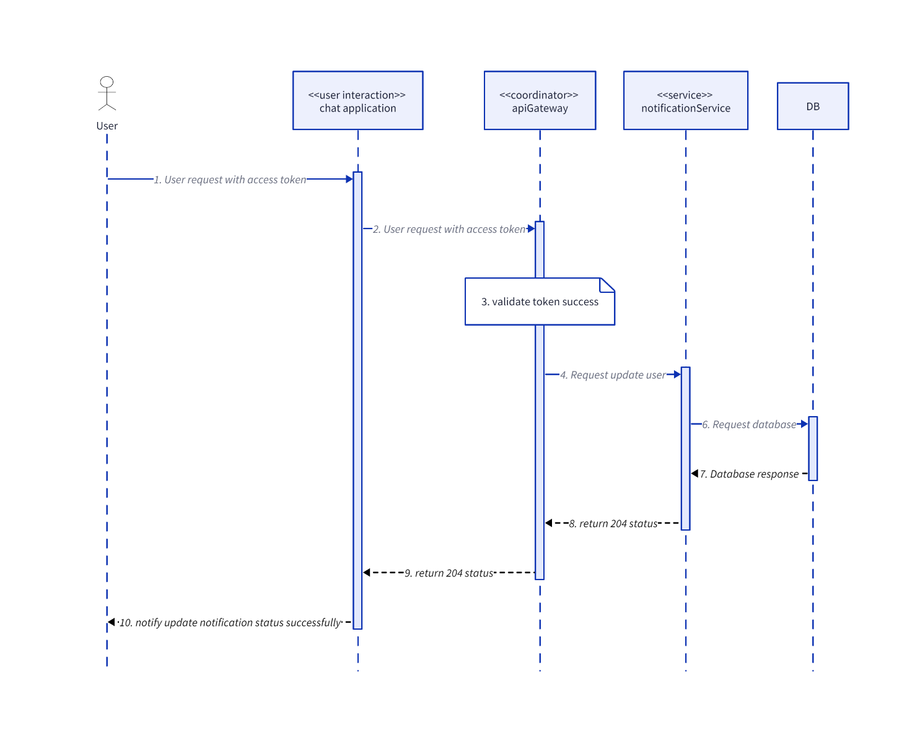

## Post

### CreateComment

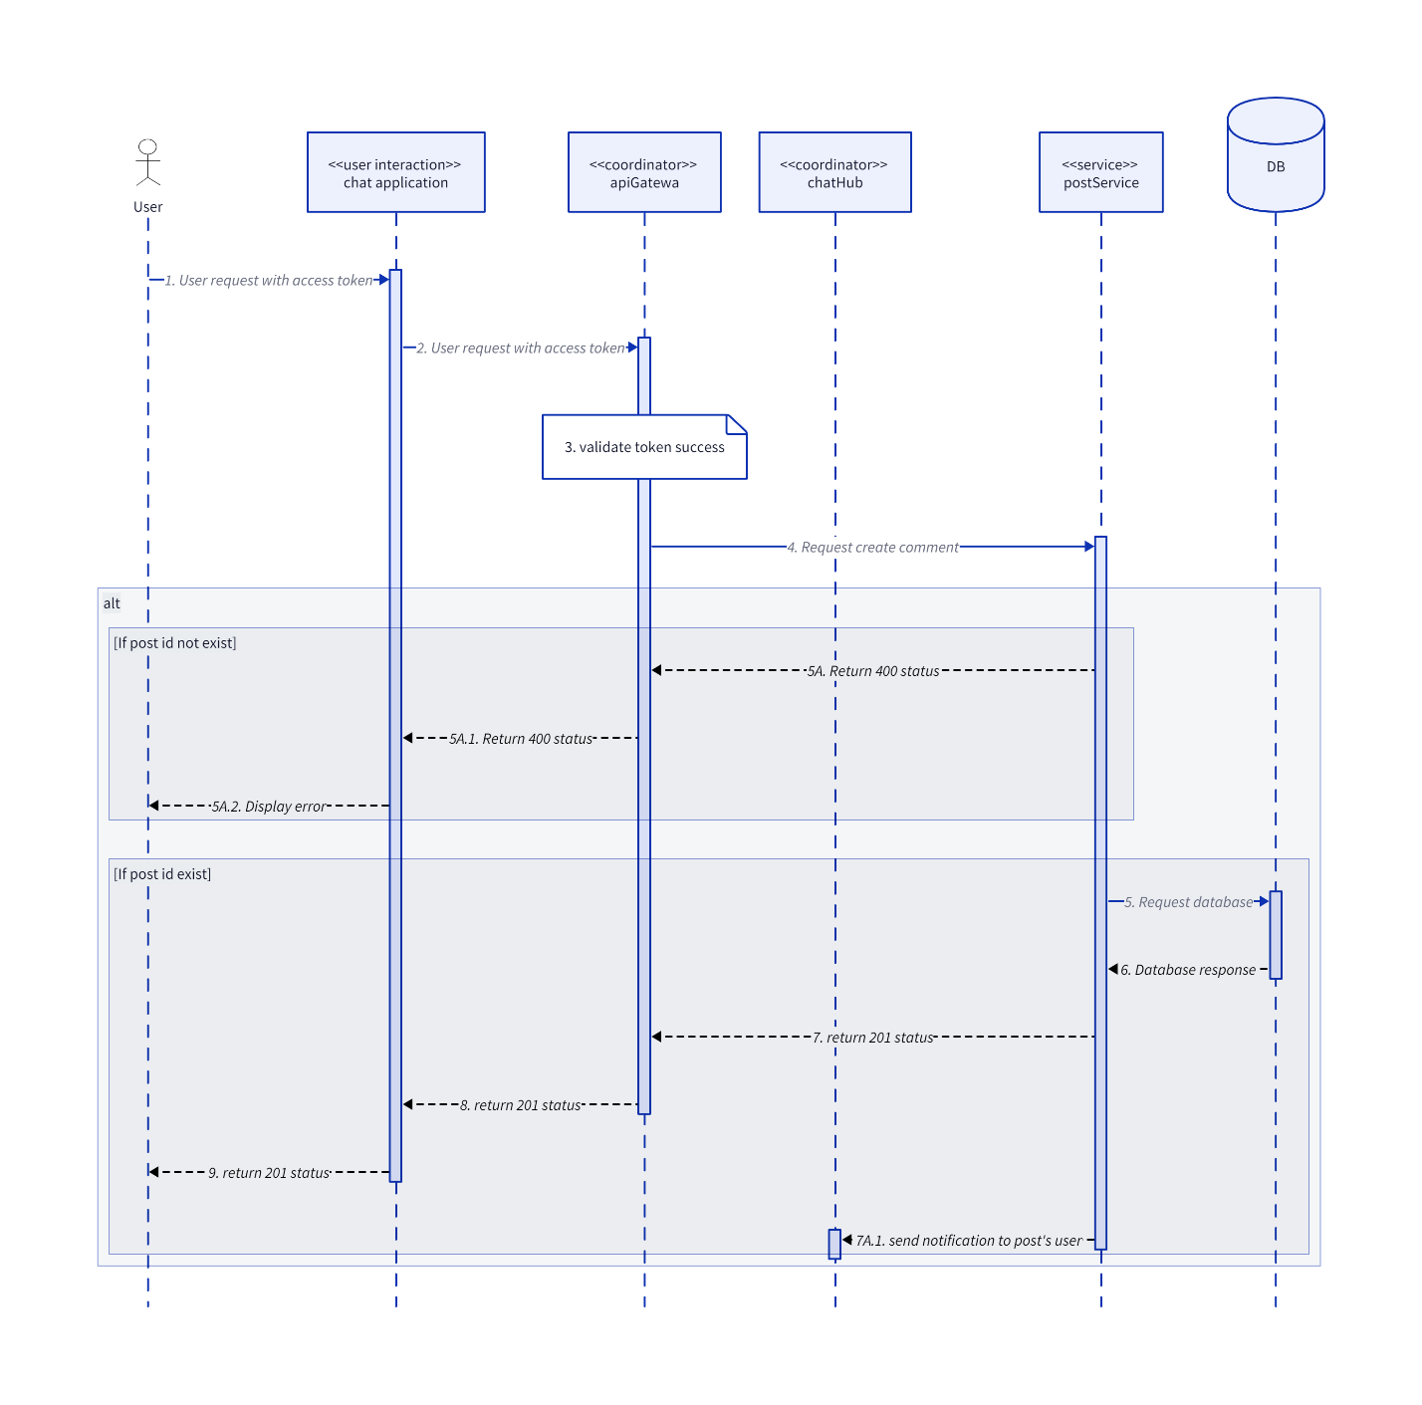

### CreateInteractionEmoji

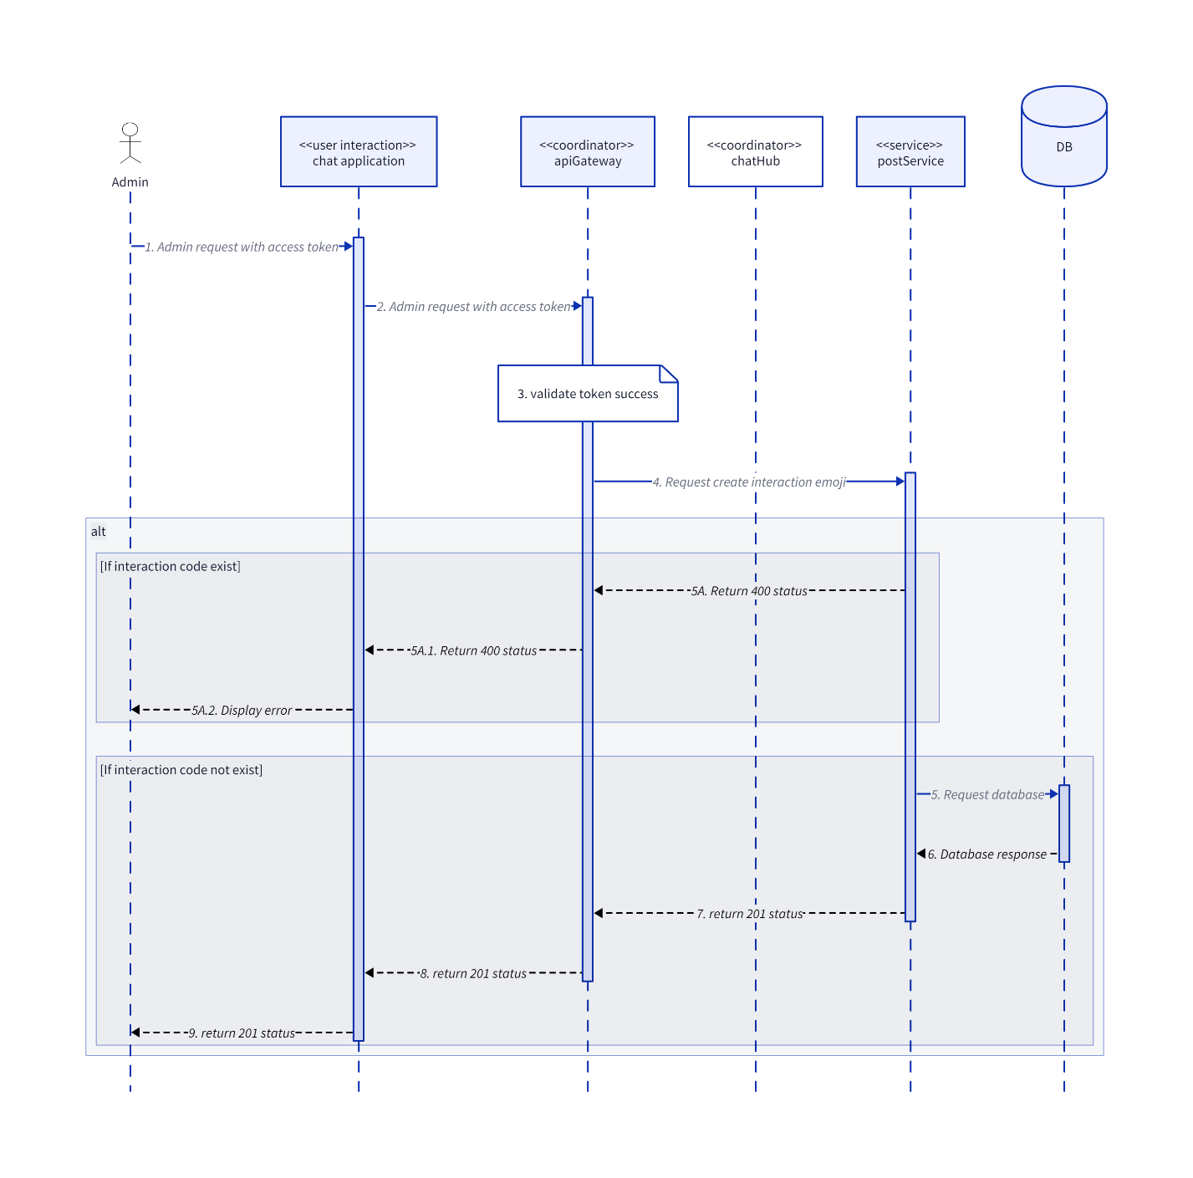

### CreatePost

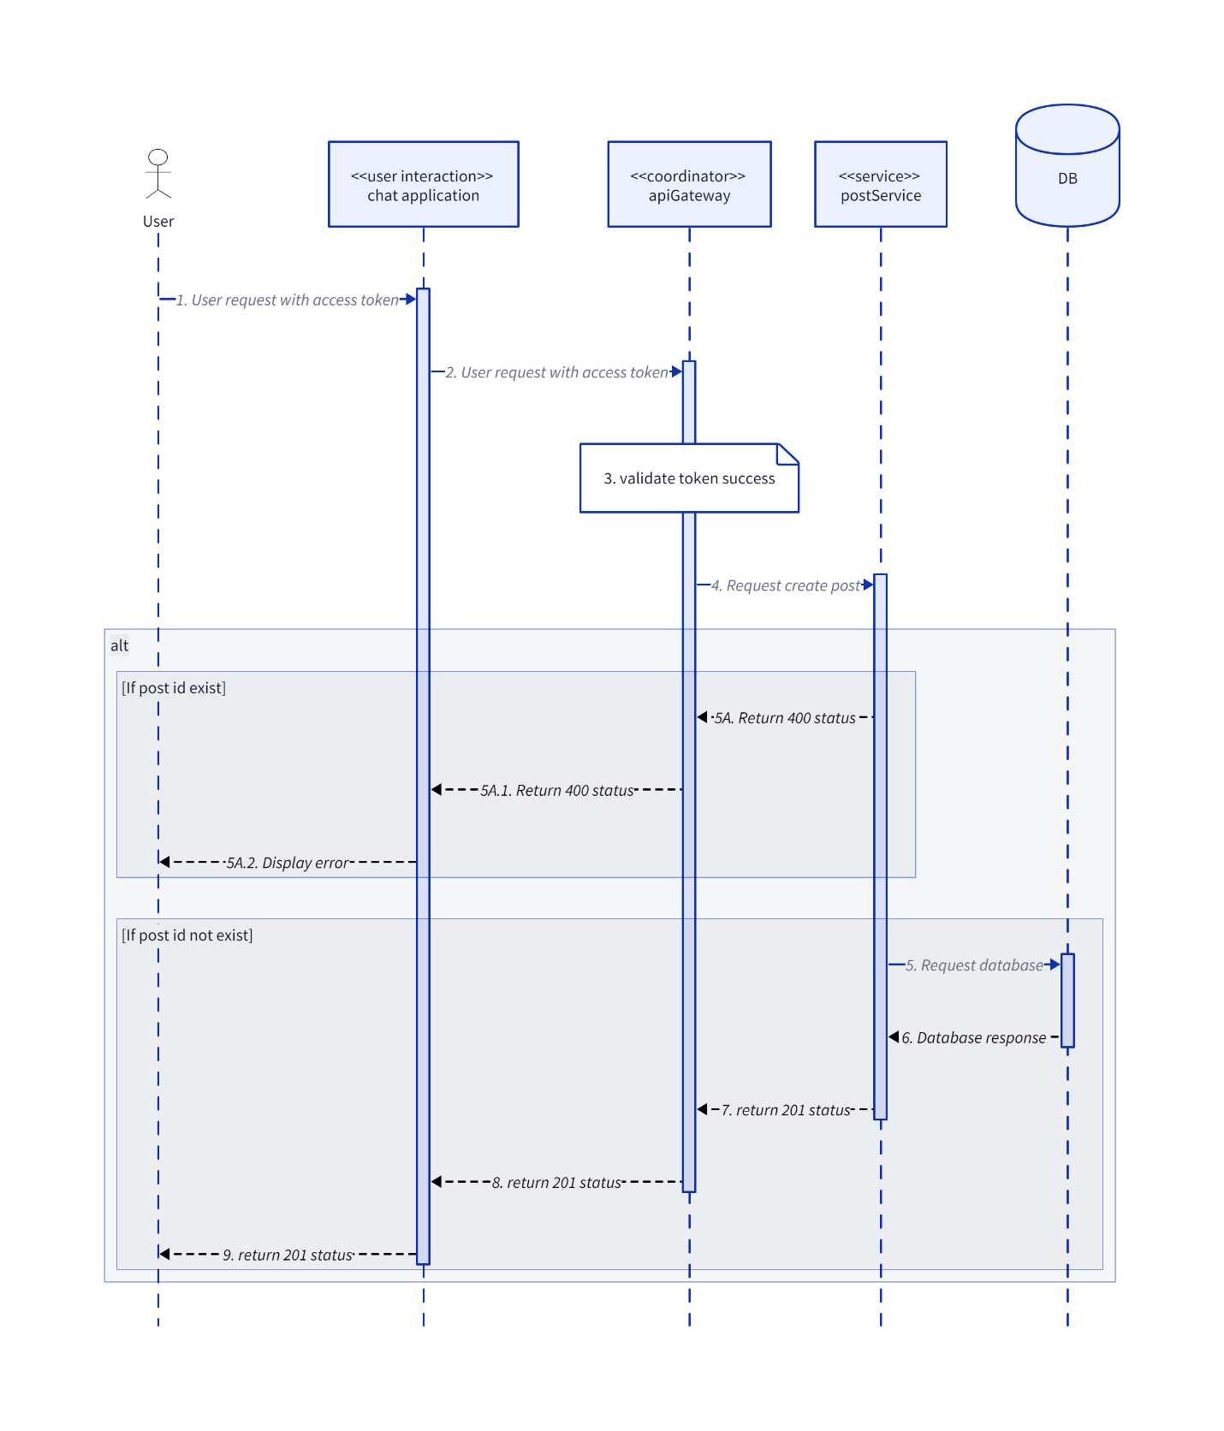

### CreatePostInteraction

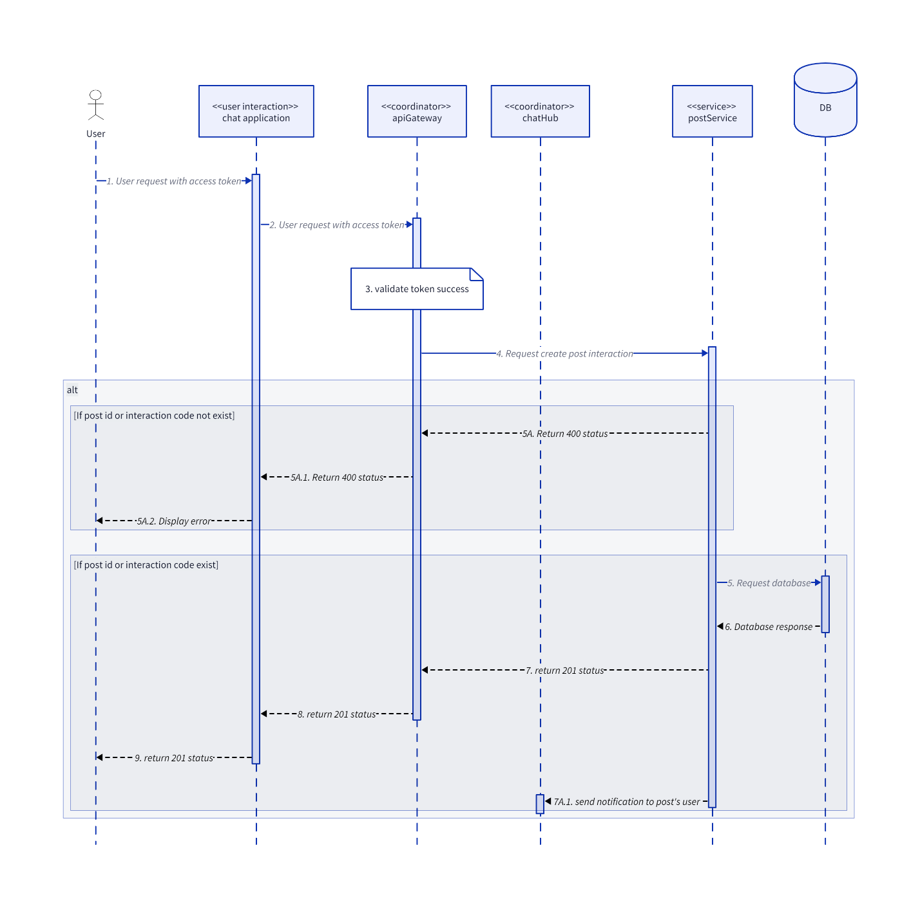

### CreatePostReport

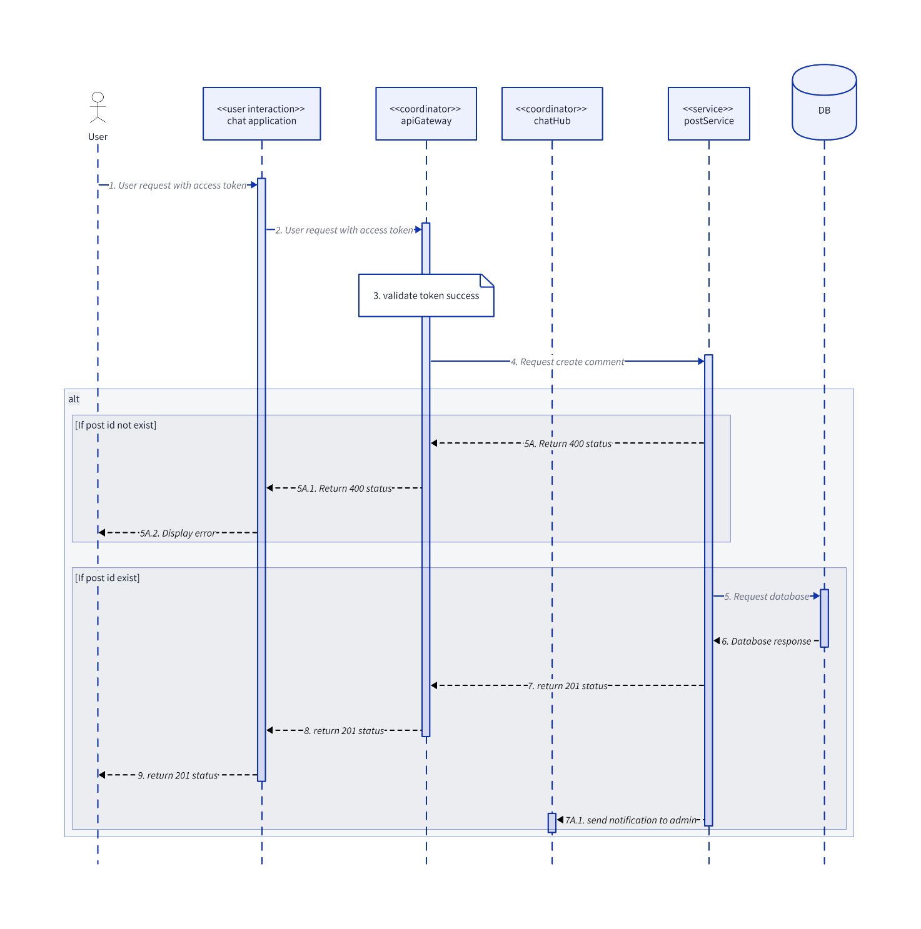

### CreateTag

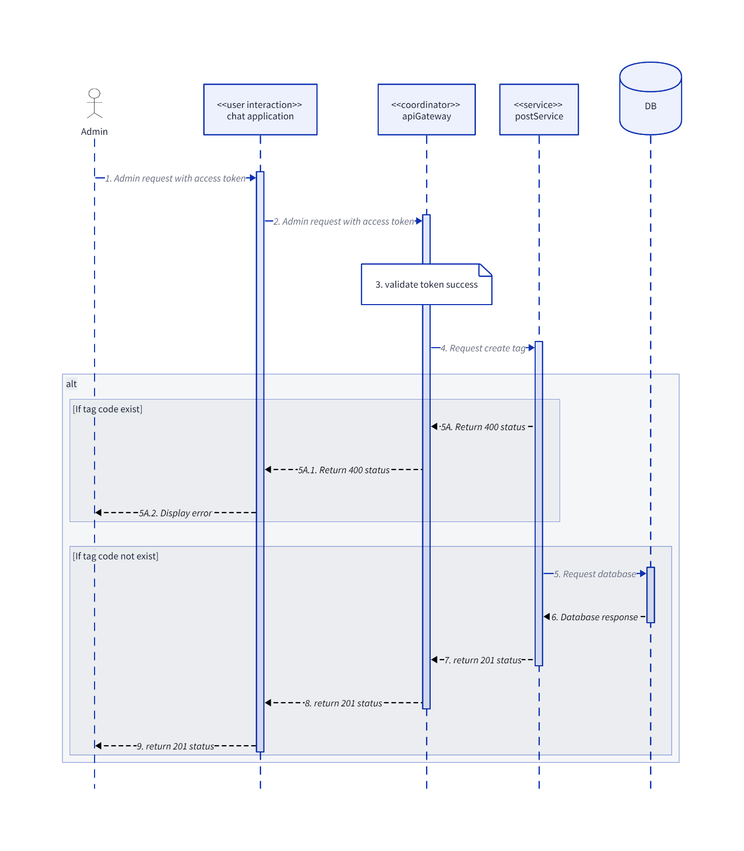

### DeleteInteractionEmoji

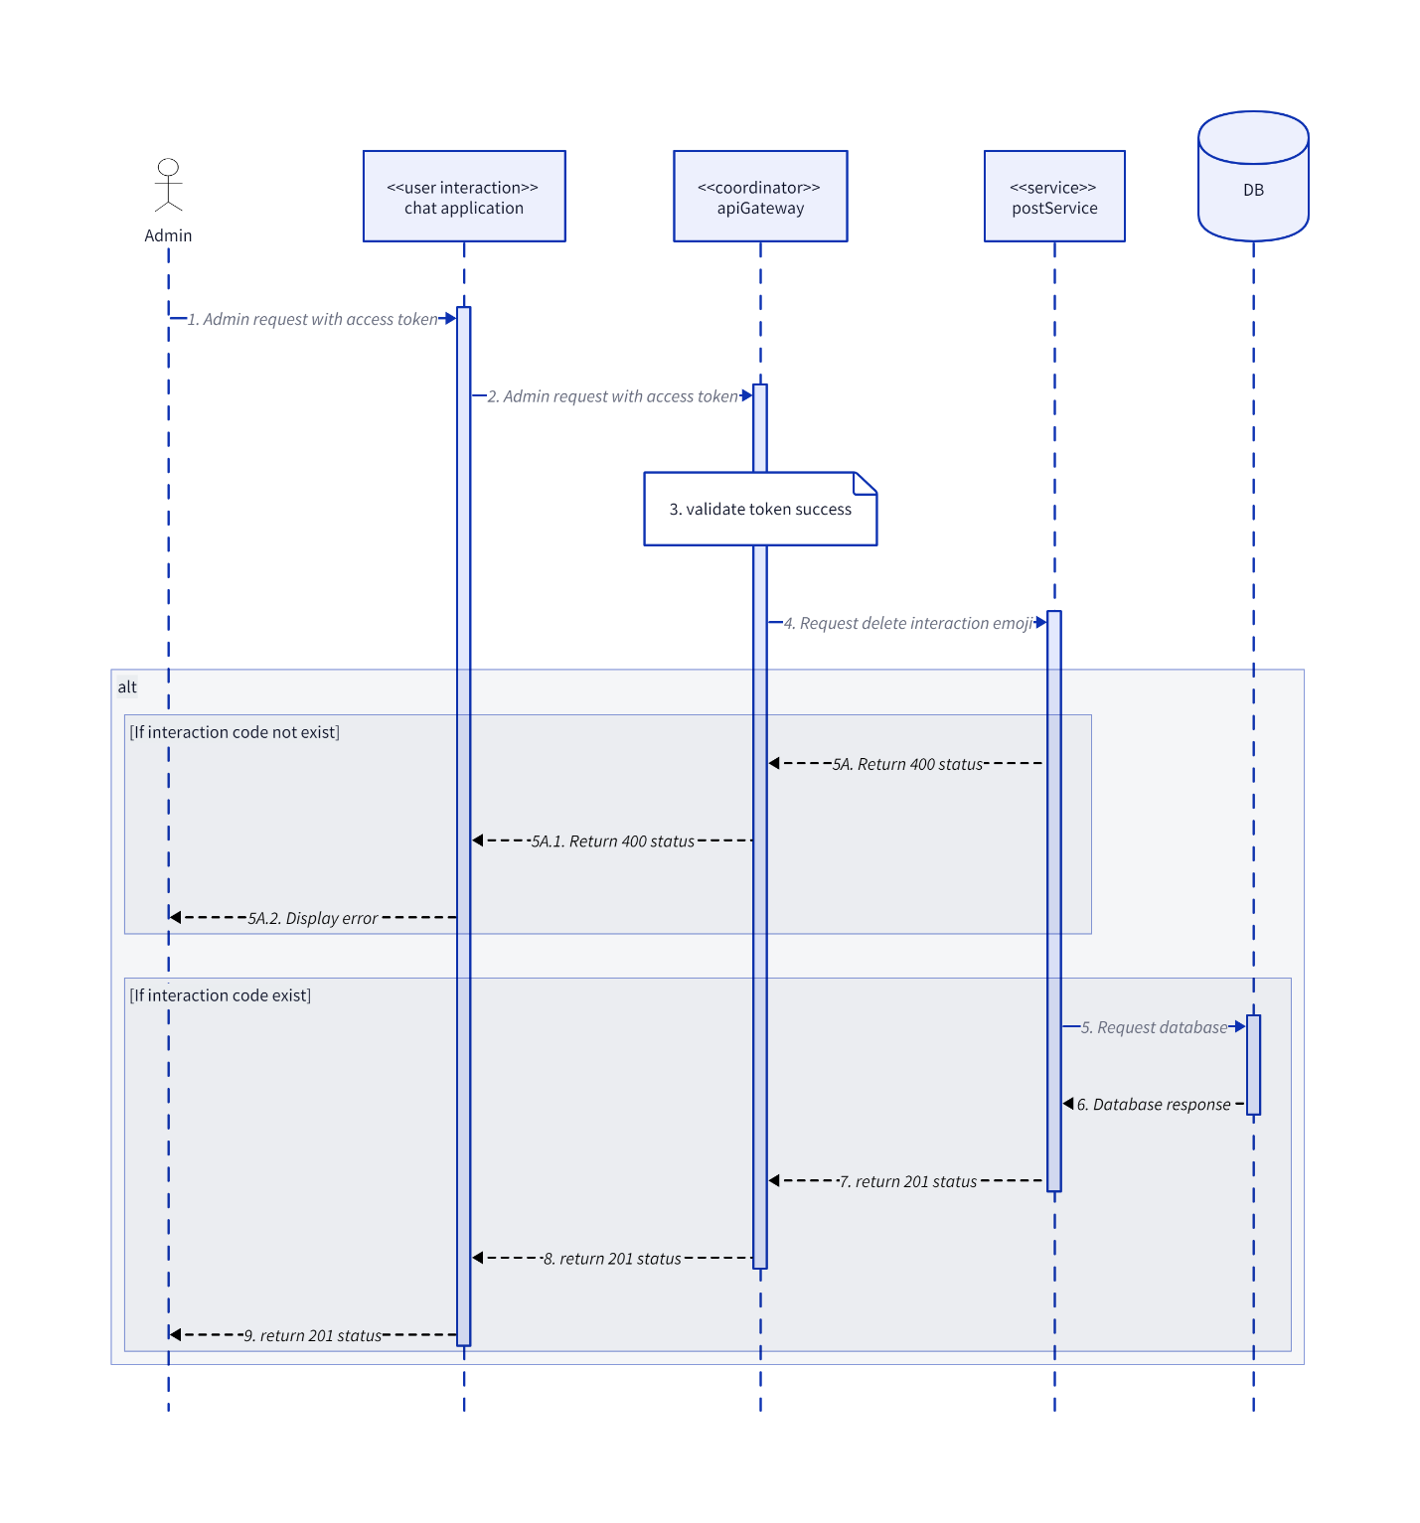

### DeleteTag

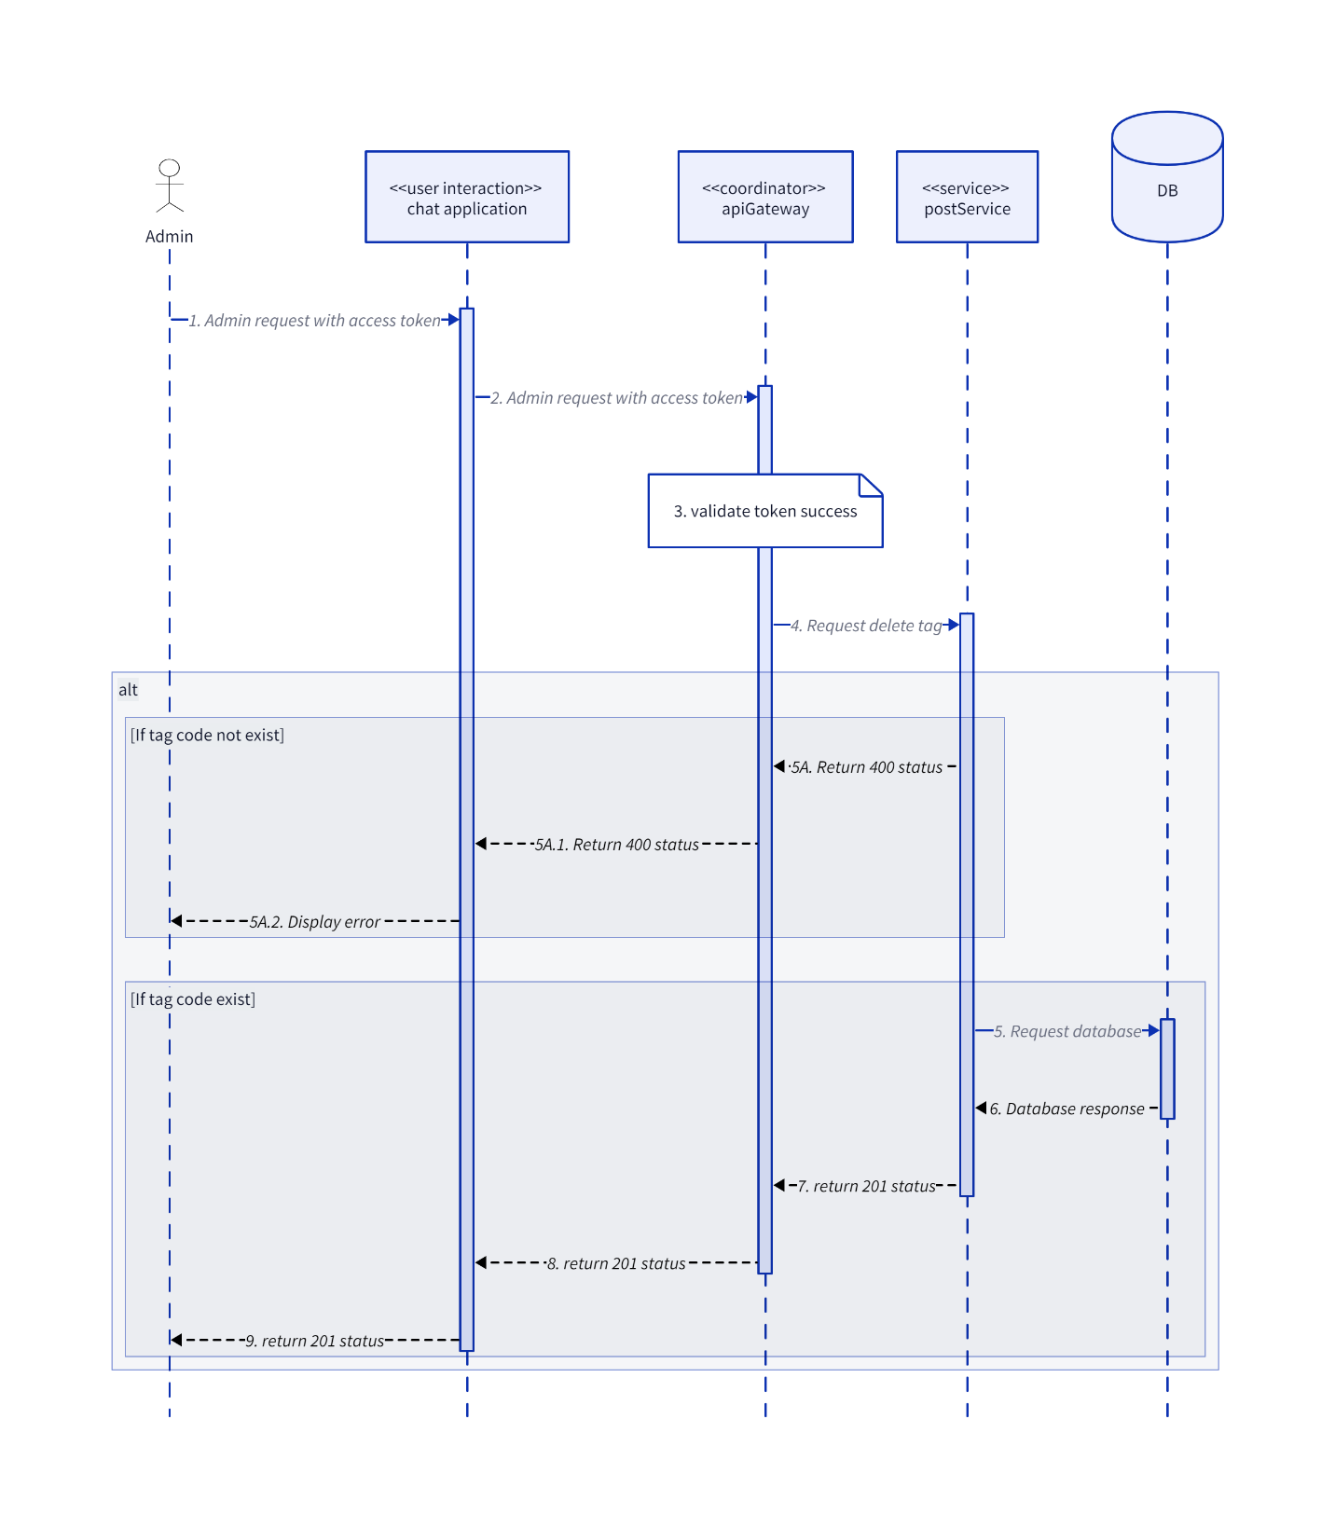

### DisablePost

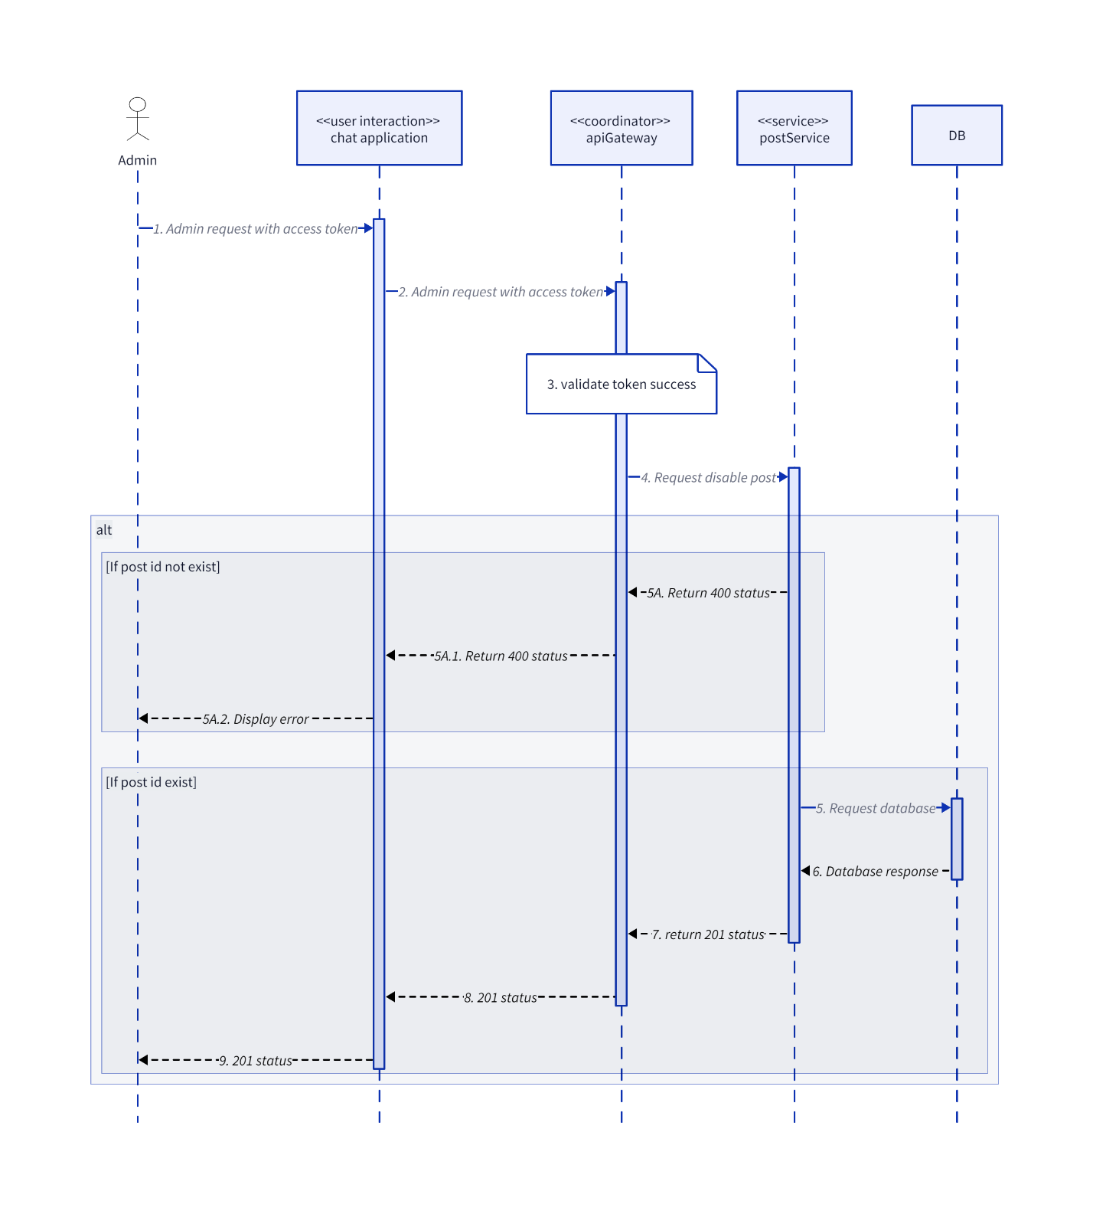

### GetListInteractionEmoji

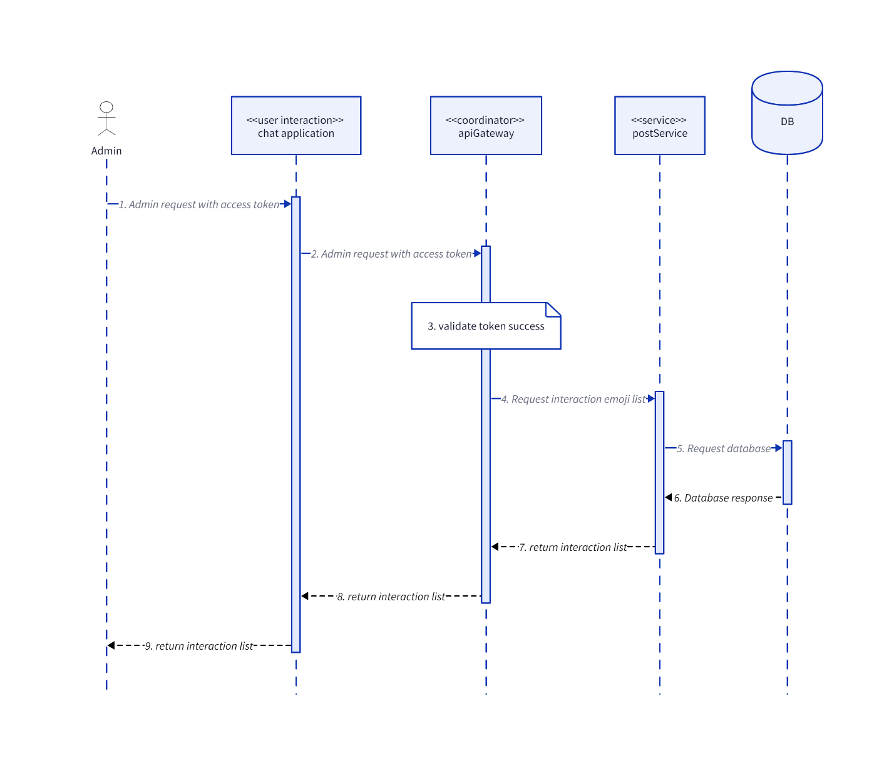

### GetPostById

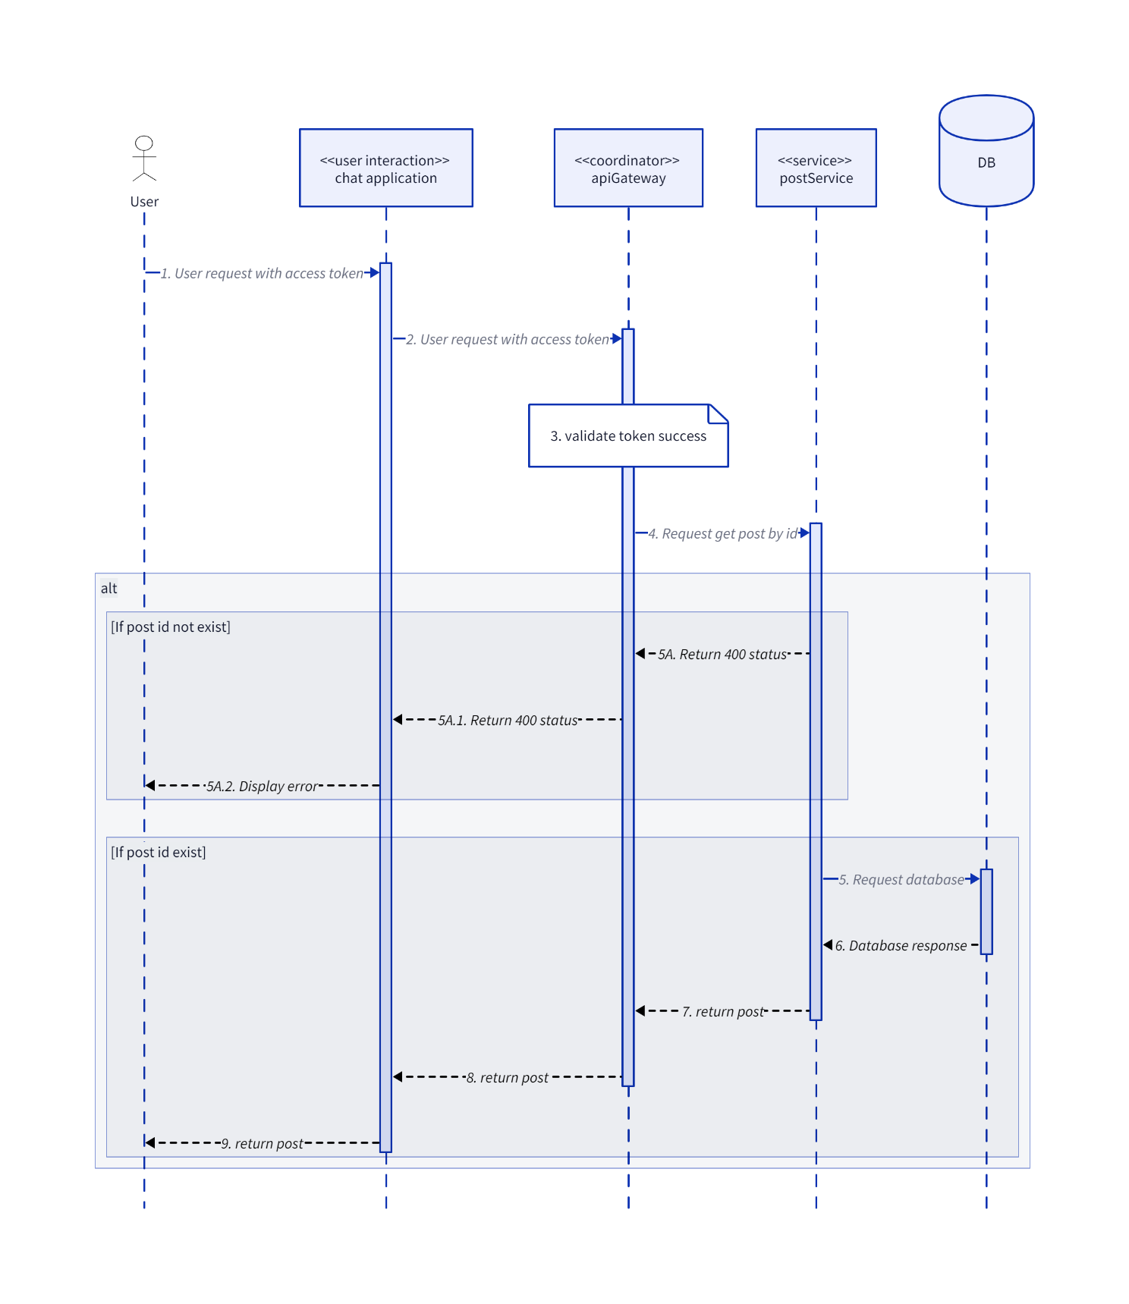

### GetReportPostList

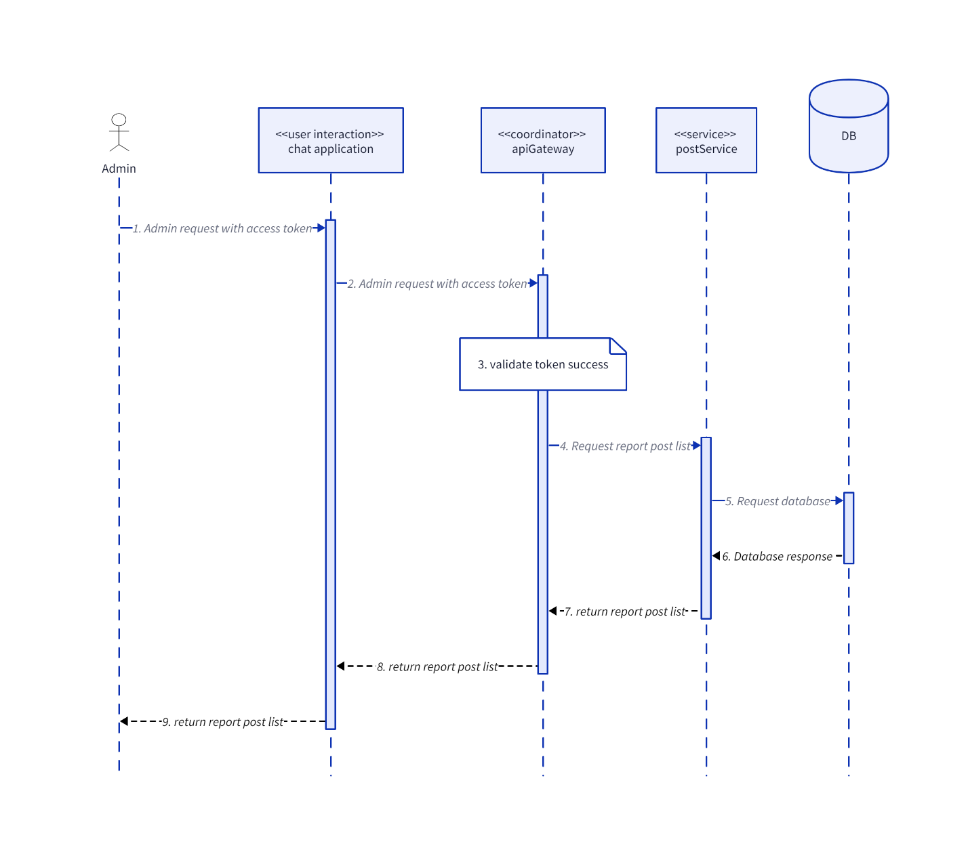

### GetTagList

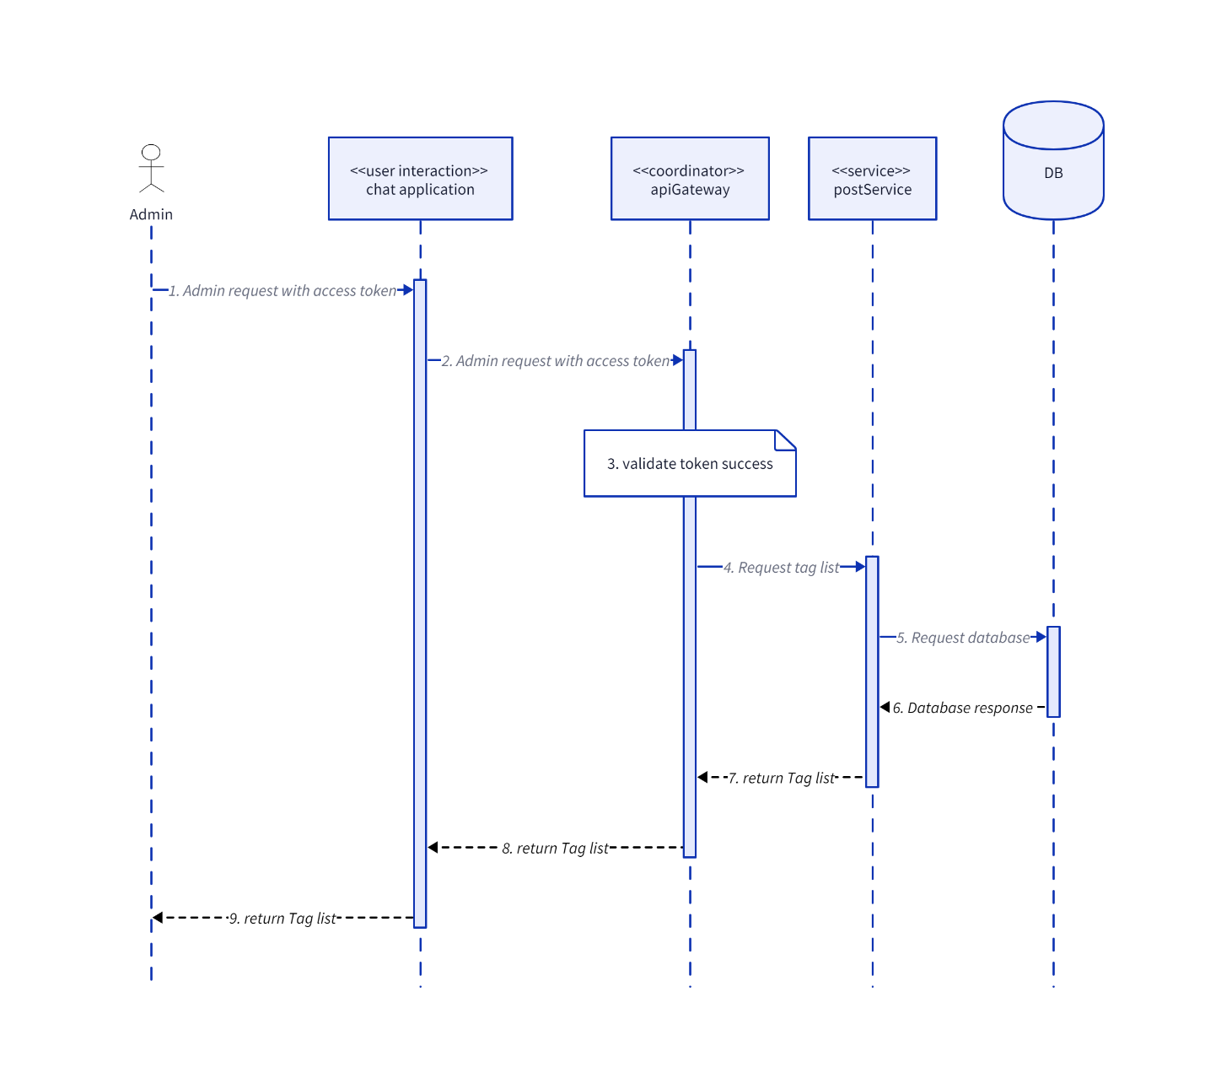

### UpdateInteractionEmoji

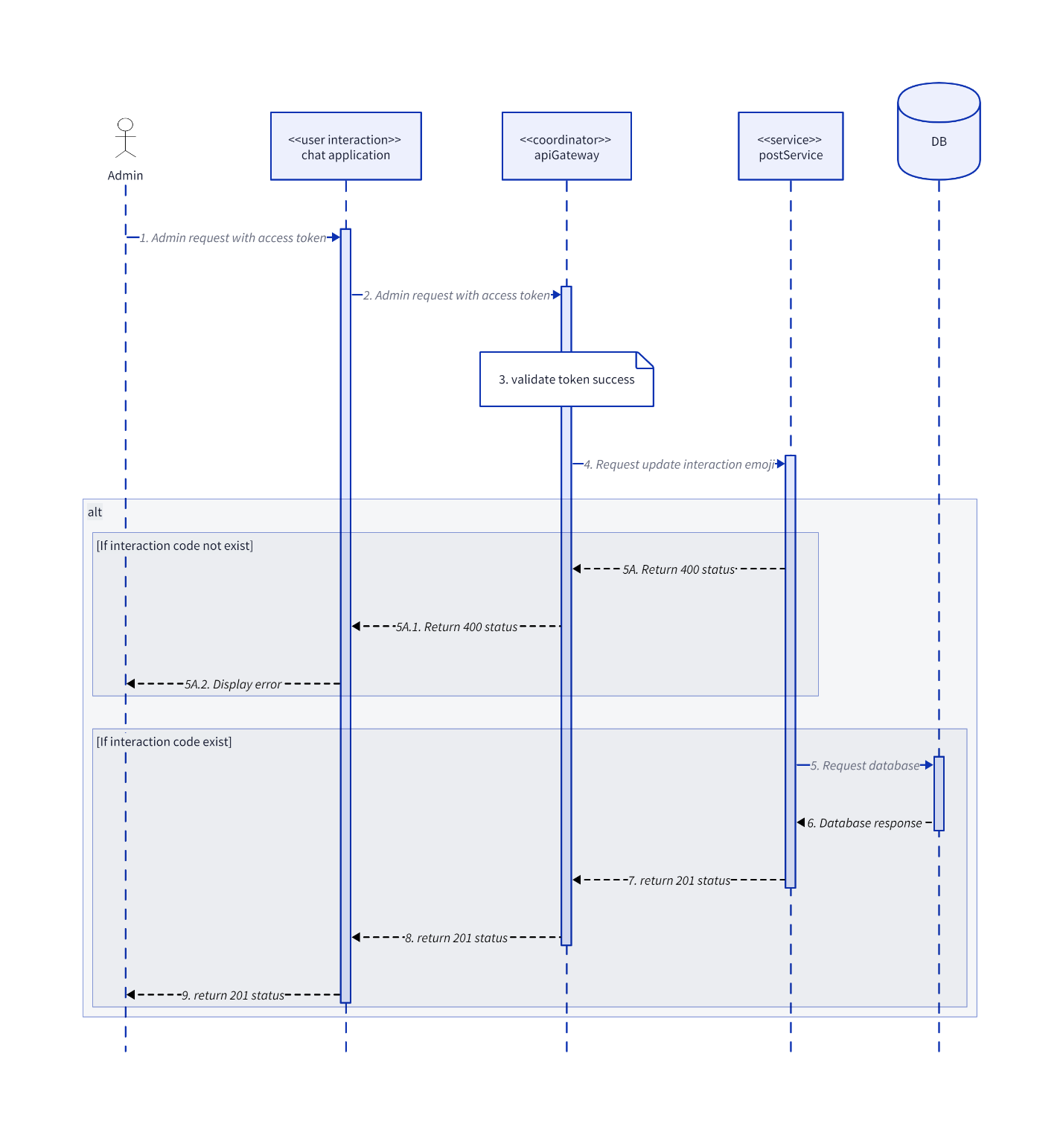

### UpdatePost

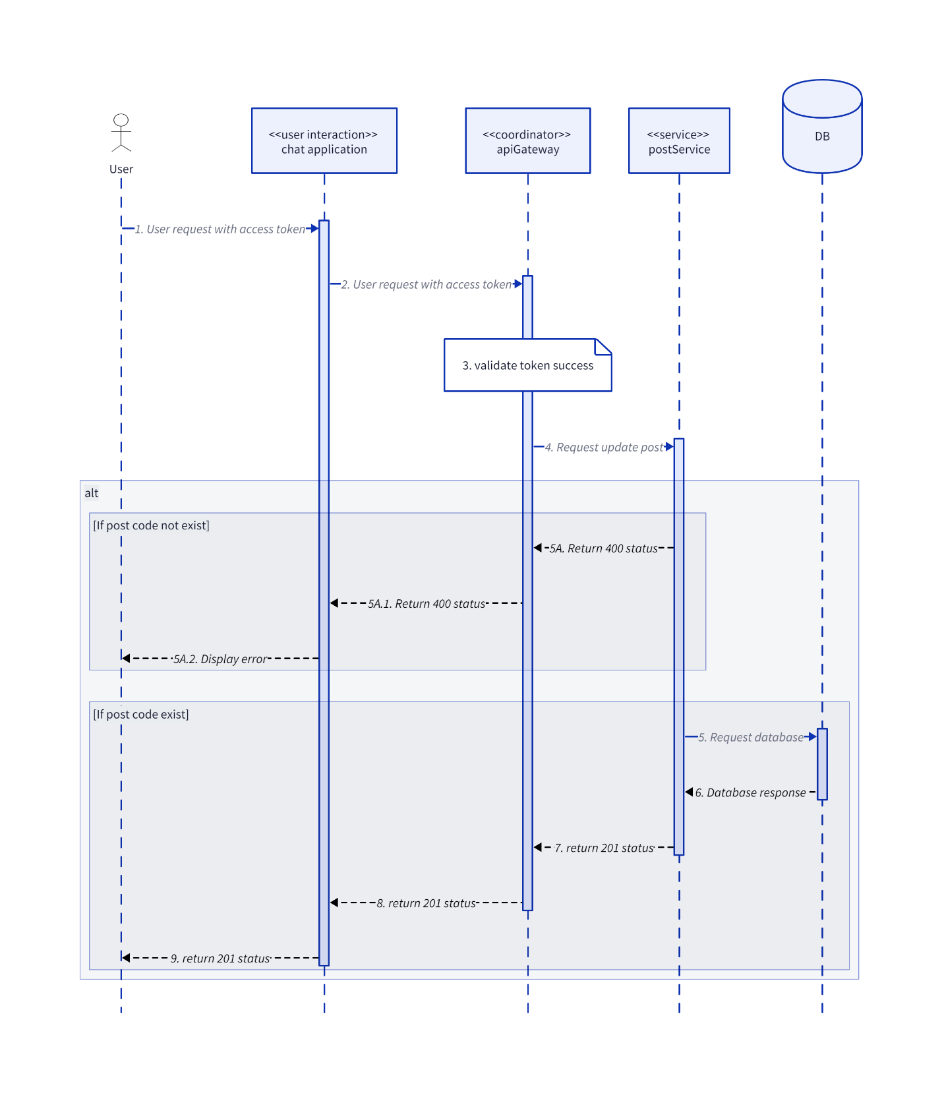

### UpdateTag

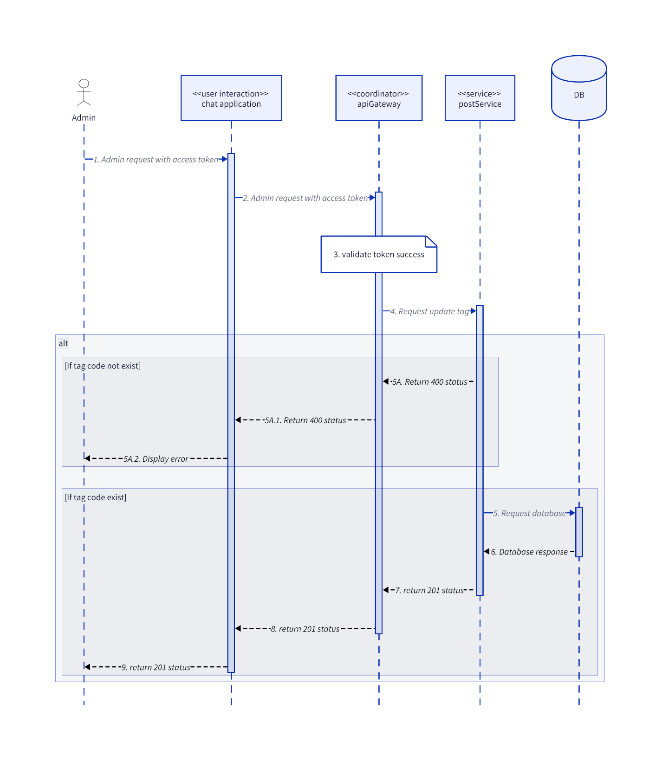

## Websocket

### Call

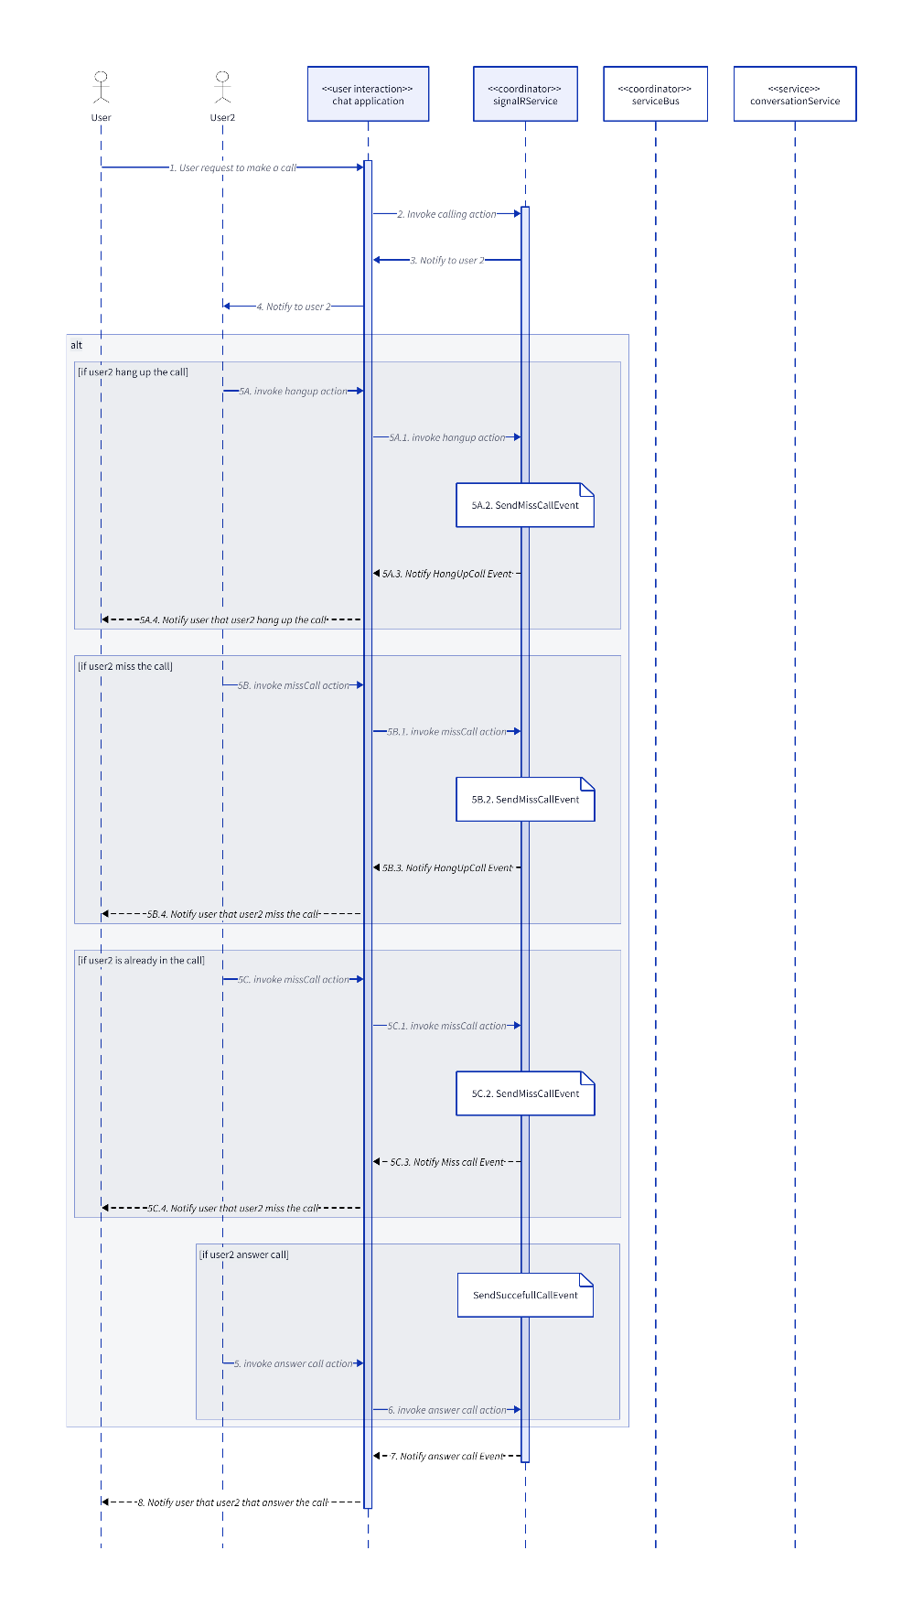

### SendCallEventMessageToClient

